CURRICULUM VITAE
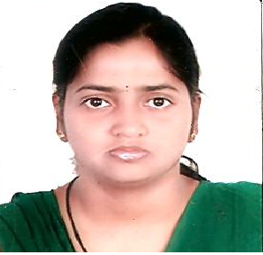
RUTUPARNA DAS
ADDRESS:
QRT.NO- B14/11,
Doordarshan Staff Quarters,
PO-Sainik School
MOBILE: 6370713995
EMAIL: rutuparna.pt@gmail.com

CAREER OBJECTIVE
To seek position of growth learning and accomplishment using my skill and potential achieve a professional excellence while working with organization.

ACADEMIC QUALIFICATION

Qualification | Name of the Institution | Year of passing | Total marks | Marks secured | Percentage
10th | Badambadi New Colony High School, Cuttack | 2009 | 600 | 412 | 68.66
+2(Science) | Sri AI of HSR Matrubhawan, Cuttack | 2011 | 600 | 295 | 49.06
BSc(ITM) | Ravenshaw University, Cuttack | 2014 | 2000 | 1499 | 74.95
MCA | OUAT, Bhubaneswar | 2017 | 10 CGPA | 7.82  In CGPA
Diploma in Hindi | Central Hindi Directorate, Delhi | 2019 |  |  | 69

STRENGTH
- Self-motivating
- Hard working
PERMANENT ADDRESS
AT-Mahamadabad
PO-Pippal madhab
PS-Tirtol
Dist- Jagatsinghpur-754160
PERSONAL PROFILE
Father’s Name : PRASAN KUMAR DAS
Date of Birth : 01.04.1994
SEX : Female
Marital Status : Unmarried
Language Known : English, Hindi, Odia
Nationality : Indian
Religion : Hinduism

EXPERIENCE

I was apprentice trainee at OKCL, Bhubaneswar from October 2019 till September 2020.

DECLARATION
I do hereby declare that the above information is true to best of my knowledge.

Rutuparna Das
Place: Bhubaneswar

