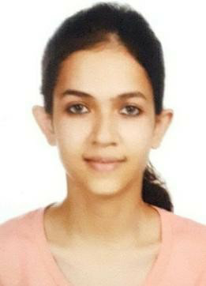
Partiksha Gupta
Address – 42 D/C Gandhi Nagar Jammu , J&K
Email-gpratiksha89@gmail.com
Mob No.+91- 9697521189

Career Objective

To pursue management career by joining a well settled and highly professional organization and strive to achieve professional skills for working towards excellent results.

EDUCATIONAL QUALIFICATION

Degree | Institute / Board | Year of qualification | CGPA / Percentage
MBA | Shri Mata Vaishno Devi University | 2017-19 | 7.95 CGPA
B.Com. | University of Jammu | 2014-17 | 67.2%
₁₂th | CBSE | 2014 | 74.2%
₁₀th | CBSE | 2012 | 9.4 CGPA

ACADEMIC EXPOSURE

- Internship (May-July 2018) Organization : HDFC Bank Ltd Duration : 2 Months
Topic : New To Bank-Acquisition
- Attended Entrepreneurship Awareness Camp (September 2017)
- Attended International Case Study Conference (2017)
- Attended National Business Plan Competition at University of Jammu (2015)

WORK EXPERIENCE

Organisation | Designation
ICICI BANK LTD.  (27th May 2019-Till Date) | Relationship Manager- Mortgages Chandigarh

Skills: MS-Office

Hobbies / interests: Sketching, Playing badminton and Swimming

Marital Status: Single

Languages known: English, Hindi

PERSONAL INFORMATION

Father’s Name : | Ajay Gupta
Permanent Address : | H.No.42 D/C Gandhi nagar, Jammu, Jammu & Kashmir
Nationality : | Indian
Marital Status : | Unmarried
D.O.B : | 07-11-1996
Languages Known : | English, Hindi
Passport No. : | K3928492

DECLARATION

I hereby declare that the information furnished above is true to the best of my knowledge.

Date: 17th July 2020
Place: Jammu Partiksha Gupta

