CURRICULUM VITAE

SASTRIJI MYLABATTUL 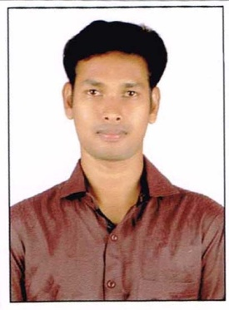

[Sastri.sastriji@gmail.com](mailto:Sastri.sastriji@gmail.com)

|  |
| --- |
| CARRER OBJECTIVE: |

“To work in such a manner that provides me to use my skills and knowledge at the same time enhance all the qualities and thus being a part in a growth of the organization as well as my own”.

|  |
| --- |
| ACADEMICS: |

|  |  |  |  |  |
| --- | --- | --- | --- | --- |
| COURSE | SCHOOL/COLLEGE | BOARD/UNI.. | YEAR OF PASSING | PERCENTAGE |
| BTECH(PETROLEUM ENGINEERING) | S.V.K.R.COL OF ENGINEERING TECH.. GOLLALAKODERU | J.N.T.U.KAKINADA | 2014 DEC | 60% |
| INTERMEDIATE | SRI SAI CHAITANYA Jr’col BHIMAVARAM. | BOARD OF INTERMEDIATE | 2010 MARCH | 53% |
| S.S.C | Z.P.H.SCHOOL,LANKALAKODERU. | S.S.C.BOARD | 2006 | 60% |

PROJECT PRESENTATION:

* Have a under take a internship on O.N.G.C RAJAHMUNDRY ASST. “(GROUP GATHERING STATION KESINAPALLI)PRODUCTION” .
* Have undertake main project on O.N.G.C RAJAHMUNDRY ASST. “(GAS COLLECTING STATION MORI)”

STRENGTHS:

* Can make work environment very friendly through my skills and my nature.
* Have good relationship skills.
* Highly adaptabul.

TRANING UNDERGONE:

* Have undergone internship for 15 days “GROUP GATHERING STATION KESINAPALLI”

AREAS OF INTERSTS:

* ACCOUNTATENTS, DATA ENTRY,M.S.OFFICE,PRODUCTION,DRILLING.

EXTRA CARRICULAR ACTIVITES:

* Playing guitar,playing basket ball,cricket,

PERSIONAL PROFILE :

* NAME : M.SASTRIJI
* FATHER NAME : M.SEKHAR BABU
* MOTHER NAME : M.REVATHI
* BATE OF BIRTH : 06\07\1991
* NATIONALITY : INDIAN
* GENDER : MALE
* LANGUAGES

KNOWN : ENGLISH,TELUGU

* MOBILE : 8500584642,7075542777

DECLARATION:

I hereby declare that the above mentioned information is true to the best of my knowledge.

DATE : yours obediently

Place :lankalakoderu. M.SASTRIJI