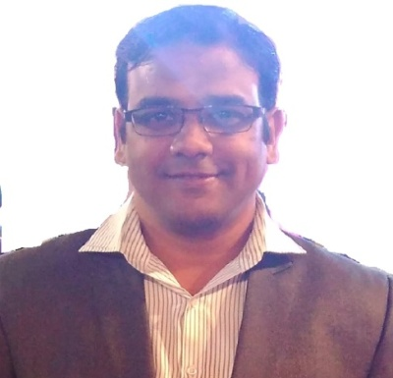**APURVA TARAN**

**Permanent Add:=**

**BE -283, IIND Floor, Gali No - 6, Hari Nagar,**

**New Delhi – 110064**

**Mob No: -+91- 9999286260**

[**apurvataran@gmail.com**](mailto:apurvataran@gmail.com)

**CAREER OBJECTIVE:-**

Looking forward to join a progressive Organization where I can put all the efforts, ability, knowledge, sincerity & experience into work for helping the organization to achieve its growth and prosperity to my full potential for both me as well as organization.

**WORKING EXPERIENCE:**

* **Marshalls Enterprise India Pvt Ltd.**

**Sept.’2012 to till Date Working as a Sr. Sales Executive.**

**Responsibilities:**

* Listening to customer’s requirements and presenting appropriately to make sales.
* Maintaining and developing relationships with existing client’s in person via calls and mails.
* Cold calling to arrange meetings with potential client’s to prospect for new business.
* Acting as a contact between a company and its existing and potential markets.
* Negotiating the terms of agreement and closing sales.
* Handling complete order process including estimate to execution of orders.
* Handling projects order placement and their complete follow-up.
* Coordinating with Admin/Accounts and Installer to schedule the work.
* Handled exhibition task and other branding task as per schedule annual calendar.
* **S. K. Education Pvt. Ltd**

**Aug 2009 to Aug 2012 Worked as a Marketing & Support Executive**.

**Responsibilities:**

* Branding & Promotion of Products.
* Maintaining Client Data base.
* Appointing New Franchise.
* Achieving Business Targets from old & new Franchises.

**EDUCATIONAL QUALIFICATION:-**

* M.B.A. in Marketing from Sikkim Manipal University.
* B.A. from Rajasthan University.
* 12th Arts from C.B.S.E. Board.
* 10th from C.B.S.E. Board.

**KEY SKILLS & STRENGHTH**

Presentation & Communication Skills, Interpersonal Skills, Analytical Skills.

Willingness to learn, Optimistic and target oriented.

**Computer Skill :**

* Basic Knowledge of Computer
* Internet, MS Word, Excel

**PERSONAL DETAILS:-**

* Father Name : Shri. Ajit Kumar Taran (Retired Govt. Empl.)
* Mother Name: Smt. Rita Taran (Housewife)
* Date of Birth: 18/03/1985
* Marital Status: Married
* Languages Known: English, Hindi, Bengali
* Nationality: Indian

Declaration:

I hereby declare that all above information is correct and true to the best of my knowledge and belief.

Place:-

Date:- Signature