**RESUME**

**SURESH BHARGAV**

**S/O TARA CHAND BHARGAV**

**BIHIND CITY KOTWALI BHARGAV MOHALLA, BKN (RAJ)**

**PH:9828555133, 7665497905, MAIL : SURESHBHARGAV786@GMAIL.COM**

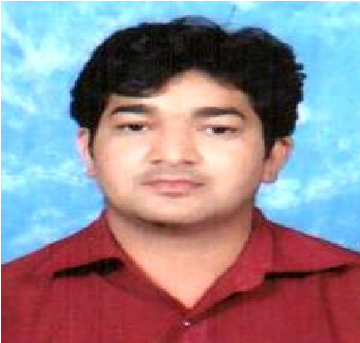

CAREER OBJECTIVE:-

TO SUCCED IN AN EVIRONMENT OF GROWTH AND EXCELLENCE AND EARN A JOB WHICH PROVIDES ME JOB SATISFACTION AND SELF DEVELOPMENT AND HELP ME ACHIVE PERSONAL AS WELL AS ORGANIZATION AL GOALS.

EXPERIENCE:-

* AGGERWAL PLUS AGGERWAL PACKING INDUSTRIES(2012-13)
* PINK MODEL B.ED COLLEGE, BIKANER(2012-13)
* RAKESH GARG & ASSOCATIES ( RGA) VODAFONE (2013-14)
* G.P. COMMUNICATION AIRTEL PREPAID SALES (2014-15)
* VODAFONE MOBILE SERVICE LIMITED (2015-2021)
* **CURRENTLY**:- RELIANCE JIO INFOCOMM LTD (2021)

ACHIEVEMENTS: -

* CONSISTANTLY IMPRESSIVE PERFORMARE (2013)
* SALES AWARD (2014)
* BEST CASHIER , SALES CHAMP (2016)
* M-PESHA WINNER (2017) (2018)
* POSTPAID SALES CONTEST WINNER (2019)
* BEST PERFORMARE OF AUGEST (2020)

STRENGTH: -

• HARD WORKER, FAST LEARER AND BEST RESULT IN PRESSURE

PERSONAL INFORMATION:-

DATE OF BIRTH : 07.01.1990

NAME : SURESH BHARGAV

NATIONALITY : INDIAN

GENDER : MALE

MARITAL STATUS : MARRIED

FATHER NAME : TARA CHAND BHARGAV

MOTHER NAME : LEELA DEVI

HOBBIES:-

* LISTENING TO MUSIC
* CRICKET
* PHOTOGRAPHY
* PLAYING BADMINTON
* CHESES

QUALIFICATION:-

|  |  |  |  |  |
| --- | --- | --- | --- | --- |
| SR. NO | YEAR | CLASS | BOARD/ UNIVERSITY | DIVSSION |
| 1 | 2006 | 10 | RBSE AJMER | PASS |
| 2 | 2008 | 12 | RBSE AJMER | PASS |
| 3 | 2014 | B.A. | MGSU BIKANER | PASS |

PROFFESIONAL QUALIFICATION:-

**(NATIONAL INSTITUTE OF FINANCE & ACCOUNTS)**

(BUSINESS ACCOUNTING, BANKING, INCOME TAX, SALES TAX, VAT, EXCISE, SERVICE TAX, INVESTMENT, INSURANCE AND LEGAL DOCUMENT

WITH 8 ACCOUNTING SOFTWARES.)

DECLARATION:-

I HEREBY DECLARE THAT THE INFORMATION IS TRUE TO THE

BEST OF MY KNOWLEDGE, IF GIVEN A CHANCE I WILL DO BY BEST TO SATISFY YOU WITH MY HARD WORKING AND CONDUCT.

DATE:

## PLACE: (SURESH BHARGAV)