**Tarunpreet Singh** 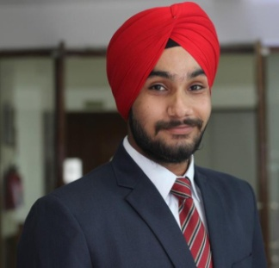

**Mobile: 9650416684**  **Email:wahi.tarun84@gmail.com**

**CAREER OBJECTIVE**

Seeking a marketing position with an organization where demonstrated skills in marketing, administration and sales can be used to increase profitability and increase growth

**ACADEMIC**

|  |  |  |  |  |
| --- | --- | --- | --- | --- |
| **Qualification** | **Year** | **University/Board** | **Institute** | **Percentage/CGPA** |
| PGDM (Marketing and IB) | 2015-2017 | AICTE & AIU approved | Asia-Pacific Institute of Management, New Delhi | 6.37 |
| BBA | 2011-2014 | Maharshi Dayanand University | Indraprastha Institute of Technology & Management | 64% |
| 12th | 2011 | CBSE | Guru Harkrishan public school , New Delhi | 54% |
| 10th | 2008 | CBSE | S.S. Mota Singh senior secondary school , New Delhi | 61% |

**Experience**

**RSDC (Rubber Skill Development Council)**

**Duration:** 1.5 Year

**Designation:** Executive Operations

**Roles and Resposibilties:**

* Handling social media sites:Facebook, Twitter, linkedin & Youtube.
* Connect new industry.
* Works under government scheme –NAPS (National Apprenticeship promotion scheme)
* Organising and attending promotional events such as Annual Awards, Meetings, Tours and visits.
* Handling activities Admin Department.

**Zodiac Impex (Pvt) Ltd.**

**Duration:** 1 Nov 2019 to Feb 2020

**Designation** : Marketing Executive

**SUMMER INTERNSHIP**

**Oyster Connect.com**

**Duration:** 8weeks

**Description:** To conduct sales promotion and determine consumer behavior about the product

**TECHNICAL SKILLS/ IT SKILLS**

* Knowledge of MS- Word, Excel & Power Point
* Basic Knowledge of SPSS

**SEMINARS ATTENDED**

* Seminar attended on Branding and Marketing conducted by Alibaba.com.

**ACHIEVEMENTS**

* 2nd Runner up in Marketing Quiz at Asia Pacific Institute of Management
* Part of runner up team in football, volleyball in inter college sports event

**PROJECTS & PRESENTATIONS**

|  |
| --- |
| * Project report- Sales Promotion And Consumer Awareness About The Product * Internship at Sony for 45 days as a part of curriculum of BBA. |

**EXTRA CURRICULAR ACTIVITIES**

* College event Mini Market (Placards and Props photography).
* Performed Bhangra at various events in school and colleges.

**COMPETENCIES &SKILLS**

* Ability to initiate
* Presentation & Negotiation skills
* Team Management
* Hardworking
* Eager to learn new things
* Eagar to work with positive result oriented approach
* Enthusiastic

**PERSONAL DETAILS**

**Date of Birth :** 05 July, 1992

**Father’s Name :** Surinderjeet Singh

**Marital Status :** Single

**Permanent Address :** M-35/B, New Mahavir Nagar,Tilak nagar, New Delhi

**Postal Address :** M-35/B, New Mahavir Nagar, Tilak nagar, New Delhi

**Languages :** English, Hindi, Punjabi

**Place: New Delhi (Tarunpreet Singh)**