MANISH MINOCHA

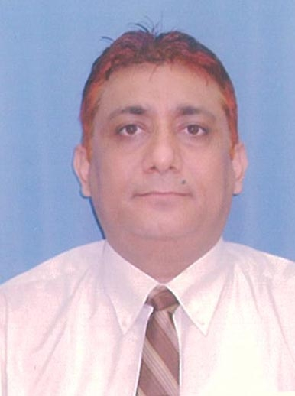

PERSONAL DATA
FATHER’S NAME | LATE SHRI J.C.MINOCHA
ADDRESS | B-003, GR. FLOOR, TIRUPATI VATIKA, INDRALOK, PHASE-6,BHAYANDAR(E)  Pin -401105,.
E-MAIL | manish.minocha2000@gmail.com
CONTACT NUMBER.  DATE OF BIRTH (D.O.B)  MARITAL STATUS  NATIONALITY | 09892523723(Mobile)  05.05.1968  MARRIED  INDIAN

Educational QualificationS
- Master in Business Management (M.B.A)  ( Specialization in Marketing)  (1991-1993 ) ( FIRSTDIVISION ) | Dr. Hari Singh Gaur University Sagar
- Certificate in Computer Programming  (Basic, COBOL, Dbase, Fortran, “C”-Unix)  ( 1987-88) (A- GRADE) | Birla Institute of scientific Research  Jaipur.
- Bachelor in Science (B.Sc.)  ( Chemistry, Botany , Zoology)  (1985-1987) | Maharaja’s College(University of Rajasthan) Jaipur.
- All India Senior School Certificate Examination(AISSCE) 1985 | Kendriya vidalaya (CBSE)
- All India Secondary School Examination (AISSE) 1983 | Kendriya vidalaya (CBSE)

EXPERIENCE :
Presently working as Senior Executive-sales in Mumbai ( in Golcha Group ISO CO. in Minerals Division company -M/s S.Zoraster & Company. Under which
20+ years Experience in Institutional Sales and sales Through Channels in Western
zone Mumbai for Mineral product. Marketing of (Purified talc) as Industrial fillers in Cosmetics, Paper, Paints, Pharma,(Excipients) Soaps & Detergent, Food ,Ceramics, Rubber,Plastic ,Agriculture, etc, Industries.
Market Research, New Product Development, Sales and Brand Promotion,developing customers for their specified requirements, valuable orders procurements , coordination of dispatches and organizing for collections of payments and sales tax forms from the customers and Corporate communications at Mumbai office as Profit centre. Working in ERP based Computerized Environment with Head Office and works based in Rajasthan.

Apart from that, Co-ordination work With same Group Diversified units in Plastic Blow Molding and Talkum filling units in Navi Mumbai for Cost management, Purchase, client developments, taxations, Stocks, logistics & liaison ,new Product development etc.And currently Coordination work with same GroupReal estate company for maintaining South Mumbai estateLeave License agreements,Administration related to security,Lift maintenance,etc.

Extra curricular aCTIVITiES

Active participations in social activities of Arya samaj.

STRONG POINTS

HONESTY , POLITENESS, HARD WORK

PERSONALITY TRAITS
To strive in perfection whatever I do. Good leadership qualities.

HOBBIES
Watching Movies Old Hindi

COMPUTER SKILLS
Operating System: MS Windows 93,7, Microsoft Excel
Notice period: 30 days.
Total experience : 23 years in Mumbai in sales and Marketing with same Group.
DECLArATION

I solemnly do here by declare that the above furnished details are true to the best of my knowledge and belief.

.
MANISH MINOCHA PLACE: MUMBAI

