**RESUME**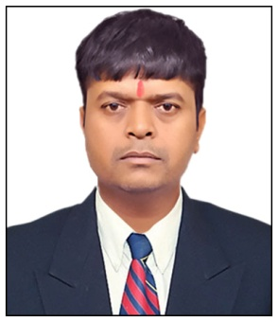

**ASHVIN JIVABHAI PATEL**

Address –Flat No-B-406,Shivampark Society,

Chanakhyapuri,Ten,Near Geb Office,Bardoli,Gujarat.

Mobile No. – 9265422212

**OBJECTIVE:**

To pursue a challenging career which provides enough opportunity for growth and in process creates a relationship between organization and me.

**ACADEMIC QUALIFICATION:**

* S.S.C. :- 69.14%
* H.S.C. :- 59.50%
* ITI Draughtsman (Mechanic) :- 64.29%
* ITI Draughtsman (Apprentice) :- 69.31%
* Diploma in Mechanical (D.L.M.):- 70%
* B.E.Mechanical:-75.89%
* Computer : AUTOCAD

**EXPERIENCE:**

* Five year experience in Kiran Motors Pvt. Ltd, Motera AhmedabadGujarat (Maruti Suzuki) as a Team Leader.
* Two year experience in Mirrikh Hyundai Bardoli as a Corporate Maneger & Team Leader.
* Two Year experience in Mannu Motor Bardoli as a Team Leader.
* Ranning Job Ten Months experience in Kataria Automobiles Pvt Ltd (NEXA) Bardoli as a SRM.

**PERSONAL PROFILE:**

* Father’s Name : Mr. Jivabhai C. Patel
* Date of Birth   : 14/06/1977
* Gender                   : Male
* Nationality             : Indian
* Marital Status        : Married
* Languages known : Hindi & English
* Hobbies : Cricket

**DECLRATION:**

  I hereby declare that all the above information’s are true and correct to the best of my knowledge and Belief.

**Da****te : 19/10/2020**

**Place: Bardoli                        (ASHVIN J. PATEL)**