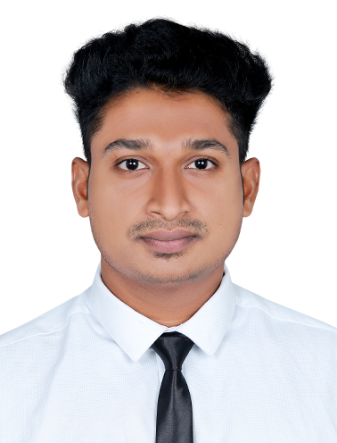

**ADDRESS:**

**KILIKKOODU VNRA B/2 ARALUMMOODE P O TRIVANDRUM, KERALA,**

**INDIA**

**695123**

**LANGUAGES**

* English
* Hindi
* Malayalam
* Tamil

# PERSONAL STRENGTH:

* Good leadership quality
* communication skill
* Adaptable to any situation

**HARSHAKUMAR R V**

**DECK CADET**

**Email id :** [**12harshakumar@gmail.com**](mailto:12harshakumar@gmail.com) , **cptharshakumar@gmail.com**

**Mobile: +919567164882**

OBJECTIVES:

**Is to become Associated with a Company where I can utilize my skills and gain further experience while enhancing the company’s productivity and reputation.**

ACADEMIC QUALIFICATION:

|  |  |  |  |
| --- | --- | --- | --- |
| **COURSE** | **NAME OF INSTITUTION** | **BOARD/**  **UNIVERSITY** | **PERCENTAGE** |
| **SSLC(10th)** | **S V V NILAYAM NEYYATTINKARA (TVM)**  **(2015)** | **Kerala State Board** | **85.7%** |
| **Higher Secondary Education(12th)** | **LMS HSS AMARAVILA TRIVANDRUM,KERALA**  **(2017)** | **Kerala State Board** | **74.0%** |
| **BSc-NAUTICAL SCIENCE** | **HIMT COLLEGE CHENNAI**  **(2017-2020)** | **INDIAN MARITIME UNIVERSITY(IMU)** | **78.38%** |

**RELAVANT DOCUMENT :**

|  |  |  |  |  |  |
| --- | --- | --- | --- | --- | --- |
| **S. No** | **DOCUMENT** | **NUMBER** | **DATE OF ISSUE** | **DATE OF EXPIRY** | **PLACE OF ISSUE** |
| **1** | **Passport** | **R1987954** | **27/06/2017** | **26/06/2027** | **TRIVANDRUM** |
| **2** | **INDOS** | **17NL1100** | **31/08/2017** | **-** | **MUMBAI** |
| **3** | **CDC** | **MUM413730** | **26/02/2020** | **25/02/2030** | **MUMBAI** |
| **4** | **Yellow Fever**  **Vaccination** | **-** | **26/08/2020** | **-** | **COCHIN** |

**MANDATORY CERTIFICATE:**

|  |  |  |  |
| --- | --- | --- | --- |
| **Name** | **Date of issue** | **Date of expiry** | **Institute** |
| **Personal survival Techniques** | **15-02-2019** | **-** | **HIMT College**  **Chennai** |
| **Fire Prevention and Fire Fighting** | **15-02-2019** | **-** | **HIMT College**  **Chennai** |
| **Elementary First Aid** | **15-02-2019** | **-** | **HIMT College**  **Chennai** |
| **Personal Safety & Social Responsibilities** | **15-02-2019** | **-** | **HIMT College**  **Chennai** |
| **SCTW Course** | **02-02-2019** | **-** | **HIMT College**  **Chennai** |
| **Basic Training in OCTF** | **03-11-2020** | **-** | **HIMT College**  **Chennai** |

**SKILLS:**

* **Capable of using Microsoft Office (EXCEL,WORD and POWERPOINT).**
* **Quick learner, dynamic and can demonstrate to be part of a team.**
* **Able to apply theoretical knowledge into practice.**

**ACHIEVEMENTS:**

* **Represented HIMT College in Naughtica 2018.**
* **Kerala State Youth Festival category Kathakali song with ‘A’ grade.**

**PERSONAL PROFILE:**

* **Name - HARSHAKUMAR. R. V**
* **Father’s Name - J.RAVIKUMAR**
* **Parent occupation - CARPENTER**
* **Date of Birth - 01-12-1998**
* **Sex - MALE**
* **Marital Status - SINGLE**
* **Nationality - INDIAN**
* **Permanent Address - KILIKKOODU VNRA B/2, ATHIYANNOOR**

**ARALUMMOODE, TRIVANDRUM, KERALA**

**Pin 695123.**

**DECLARAION:**

**I hereby declare that the above information is true to best of my knowledge.**

**HARSHAKUMAR R V**

**Date :**

**Place: Trivandrum, Kerala**