**Resume**

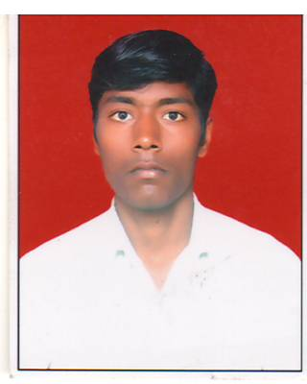

**REVANSIDDAPPA**

**Email: Revansiddappa.police@gmail.com**

**Cell No: 9448869248, 7813008884**

|  |
| --- |
| **Objective:** |

To be an integral part of progressive organization and Where I can grow by using my capabilities and skills to work with team.

|  |
| --- |
| **Experience:** |

1 Year IFB INDUSTRY ( Modeling line ), 8 Month TVS insurance co Ltd

|  |  |  |  |  |
| --- | --- | --- | --- | --- |
| **Education:** | | | | |
| S.No | Qualification | School/collage | Year | Percentage |
| 01 | S S L C | MORARJI DESAI RESIDENTAL SCHOOL TADKAL | 2011 | 47.68 % |
| 02 | P U C | SANGAM VIDYAMANDIRA PU COLLAGE GULBARGA | 2013 | 47 % |
| 04 | B.A | M.J.P COLLEGE GULBARGA | 2017 | 71.42 % |

|  |
| --- |
| **Skills:** |

Basic of computer, driving, positive attitude & Communication

|  |
| --- |
| **Hobbies:** |

Making good friends, playing waliball & Car driving

**Personal profile**

**Name :** Revansiddappa.jamadar

**Father :** Shreemantaray

**Date of birth :** 15/09/1995.

**Sex :** Male.

**Nationality :** Indian.

**Religion :** Hindu.

**Marital status :** Unmarried.

**Address :** At-Apchand,

Post-Madaki,

Tq-Aland,

Dist-Kalaburagi.

**Language :** Kannada, hindi, English.

**Declaration :** I solemnly declare that all the above information is correct to the best of my knowledge and **belief**. I am keen to continue my career and prepared to work hard in order to achieve my organization objectives and I hereby declare that the information furnished above is true to the best of my knowledge.

**Thank you**

Date:

Place: Kalaburagi

**(Revansiddappa)**