**Curriculum Vitae**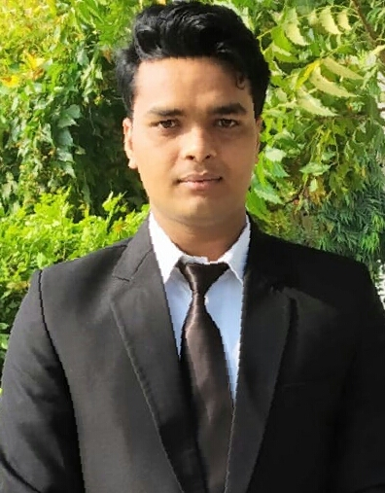

**Lokesh Kumar Sharma**

Add:- 236,Agapur Road Vikash Nagar Rampur up

E-mail :- Chef.lokesh2030@gmail.com

Contact no :-+91 9634054156,+918218220522

**Career Objective:**

To serve and contribute to an organization that provides an opportunity to integrate my conceptual and interpersonal skills and provide a platform to learn and grow with the organization.

**Academic Qualification:**

* Completed 4th Year of BHMCT degree from Institute of Tourism and Hotel Management Bundelkhand University Jhansi
* Completed 12th with 64% in Art Stream from UP Board.
* Completed 10th with 73% in Science Stream from UP Board

**Industrial Exposure:**

* 2 Months Training in Food Production in Hotel Regent Grand New Delhi Uttar Pradesh.
* 3 Months Vocational Training in Kitchen Department in Courtyard Marriott Hinjawadi Pune Maharashtra.
* 3 Months on The Job Training inB Department in Hotel Saffron Leaf Dehradun Uttarakhanda.
* Currently job in commi 2nd in Brkery & kitchen department in Hotel King's Corner Raja Park Jaipur Rajasthan.

**Job Responsibilities:**

* Ensures that all products are stored properly in the correct location at the appropriate levels at all times.
* Communicate any assistance needed during busy periods and report any incidents to the Sous Chef to ensure optimum service to guests.
* Check and ensure the correctness of the temperature of appliances and food.
* Serve food in proper portions on to correct serving vessels and plates.
* Wash and disinfect kitchen area, workstations, tables, tools, knives and other equipment.
* Maintain correct portion size and quality of the food to the hotel's standards.
* Minimize waste and maintain controls to attain forecasted food cost.

**Computer skills:**

* Working knowledge of the basic computer operations on various operating systems.
* MS-Office: - Word/Excel/Power point/Publisher
* Internet browsing & E-mail

**Personal Information**

* Name : Lokesh Kumar Sharma
* Father’s Name : Banwari Lal Sharma
* Address : 236,Agapur Road Vikash Nagar Rampur (up)
* E-mail : chef.lokesh2030@gmail.com
* Contact Nos. : +918218220522
* Date of Birth : July 07, 1998
* Gender : Male
* Civil Status : Unmarried
* Nationality : Indian
* Hobbies : Cooking, listening Music, Interacting people

**Strength/ Skills and Abilities**

* Punctual.
* Hard worker.
* Quick learner.
* Team player.

**Prerequisites**:

* Excellent understanding of various cooking methods, ingredients, equipment and procedures.
* Able to work in a fast-paced environment with speed and quality.
* Great personal hygiene and grooming standards.
* Should be able to communicate, read and write clearly and effectively.

**References:**

Chef Panna Lal

CDP in Courtyard Marriott Pune Hinjewadi

MAHARASTRA

CON: 9673852638

Email: [pannalalkumar3@gmail.com](mailto:pannalalkumar3@gmail.com)

Chef Vicky

Junior Soue Chef in Courtyard by Marriott Pune Hinjewadi

MAHARASTRA

CON: 9779920601

**Declaration**

I hereby confirm that the above information provided by me is true to the best of my knowledge.

**(L.K.SHARMA)**

**Date:**

**Place:**