RESUME

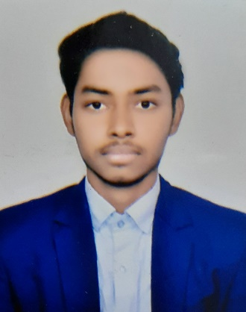 HIMANSHU KUMAR

[himanshukumar829461@gmail.com](mailto:himanshukumar829461@gmail.com)

8789759490, 9576467873

S/O-Krishna Shah

Rajaghat Lane, Ganga Bridge Colony,

Gaighat, near KL7 Hotel & Banquets

P/O- Gulzarbagh P/S- Alamganj

Dist-Patna, State- Bihar

Pin-800007



Career Objective

To utilize my technical skills and provide a professional service to customers by

applying and honing my knowledge and working in a challenging and motivating

working environment.



Education Qualification

* BSEB

I.Sc(PCM)

359(71.8%)

*2019*

* BSEB

Matriculation

354(70.8%)

*2017*



Work Experience

* **CETPA Infotech Pvt.Ltd.**

Internship

I had attended this 1-day workshop of digital marketing.

*25 April 2020 – 25 April 2020*

* **Tech-Build**

Internship

I have attending International Workshop – IT Fest 2021 on current trends in

information technology.

*16 August 2021 – 21 August 2021*

* **Litmus**

Internship

Attending workshop of “Accelerating innovation and ideas through AI”

Presented by Mrs. Komal Sharma – Co-Founder XLPAT.

*20 May 2020 – 20 May 2020*



Personal Information

Father’s Name Krishna Shah

DOB 01-05-2002

Nationality Indian

Marital Status Unmarried

Gender Male

Religion Hindu

Language Known Hindi & English

Home/Town Patna



Hobbies & Interest

* Riding bike
* Playing Cricket
* Listening music

Declaration :-

The above statement is true to the best of my knowledge and belief.

Place:

Date:

Signature