PARISAPOGU MANASHEE

Contact

OBJECTIVE

To enhance my professional skills, capabilities and knowledge in an organization which recognizes the value of hard work and trusts me with responsibilities and challenges.

 [paris.mano27@gmail.com](mailto:paris.mano27@gmail.com) 

|  |  |
| --- | --- |
| EDUCATION  L.M.K HIGH SCHOOL | 1998 |
| SSC  344 (57.85) Second |  |
| Govt. Junior College Intermediate (C.E.C) 493(49.30) Nornal | 2000 |
| Acharya Nagarjuna University B Com  901( 60.01) First | 2003 |
| Acharya Nagarjuna University  M.A. English  1179 (58.95) Second | 2006 |
| Acharya Nagarjuna University B.Ed  929 ( 66.35) First | 2009 |
| University of Hyderabad  P. G.D.C.E  401 (66.84) First | 2014 |
| EXPERIENCE |  |
| HOLY FAMILY E.M SCHOOL | 5/6/2006 |
| Teacher in English | - |

 70756 29794

 5-2-7, Nagarjuna Nagar, Sattenapalli Guntur A.P -522403

Skills

Language skills 100%

Soft skills 80% 

Achievements & Awards

BOLT AWARD from AIR INDIA in 2007

GLOBAL TEACHER AWARD from MVLA TRUST , MUMBAI in 2015

THE BEST HOUSE INCHARE for

activities From Pragati Talent School in 2011

THE BEST TEACHER AWARD from

Pragati Talent School in 2016



PRAGATI TALENT SCHOOL

Teacher in English

PROJECTS

Adavanced Writing Skills

6/7/2009 7/6/2009

- Till date

Interests

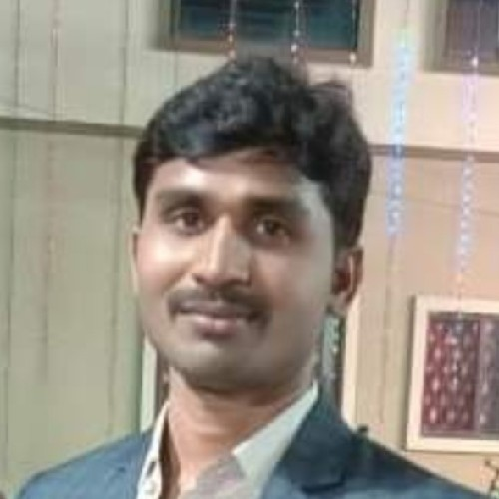

Reading books , Writing short lines and slogans , Organising workshops

Volley Ball , Cricket and Chess

It was a project cum report and it was written in 2014 under my course study. The title is " Advanced Writing Skills " for University of Hyderabad.

REFERENCE

Dr. Makkena Atchaiah - "Pragati Educational Institutions " Director

94900 56444