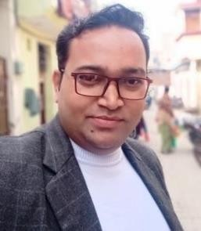Vikram Singh

### Pathankot

### Punjab:-145001

DOB:-17-09-1982

**Mobile**: 9540888020 **E-Mail**:-

[trevikram25@gmail.com](mailto:trevikram25@gmail.com)

Seeking career enhancement in Business Development, Channel Management with a world- class organization of repute preferably in the Service segment of automobiles and related areas**.**

## Professional Profile

* ***13th years’*** *of proven expertise in the area of service, customer handling, marketing and managerial prospects.*

Exposure and understanding of Sales, Service, Customer needs, Parts inventory up keeping, Upbringing of manpower, Marketing strategy development and Target Oriented planning

*Currently designated as.* ***G.M SERVICE TATA MOTORS NOIDA***

*From Sep* ***2018*** *till date*

Demonstrated abilities in Process implementation**.**

Proven performer with an excellent track record in all areas across assignments.

## Organizational Experience



W.M ***from Jan 2014 to Aug 2018 at M/S Auto Mobile Sterling Dealership of Tata Motors***

# From June 2009 to May 2014 at M/S Globe Auto dealership of Ashok Leyland. Jalandhar (HCV)

# Workshop Manager from Sep 2007 to 2009 at Cargo Motors Jalandhar Punjab (Tata Motors)

Looking for overall Service & Marketing activity in Jalandhar and Amritsar..

## Major Achievements:

TAT score increased 98 percent from 70percent Service warranty settlement within 15days (94 percent) Organised training program at Training Centre at Alwar Increased the workshop revenue by10%.

## Notable Contributions:

Good understanding and coordination with internal and external customers. Managing & executing the installations and warranty service.



To ensure optimum utilization of resources like spare parts, logistics etc..

Interact with customers; give them the required information in response to queries about accounts, products and services.

Handle and solve the complaints of customers, special orders placed by means of phone or mail.

Investigate and correct errors in the records of the customer and company, if any.



Refer the complaints regarding the product or service failure to appropriate individual for investigation.

## Academia

|  |  |
| --- | --- |
| *2007* | *B Tech From P.T.U Jalandhar* |
| *2002* | *Class XII P.S.E.B Mohali* |
| *2000* | *Class X P.S.E.B Mohali* |

***Computer Proficiency***

* *MS-DOS, Windows 10 MS-Office –2000, and Internet Applications. Worked on Auto Deal and currently working on CRM.*

### Dated:- Sign:-