RESUME
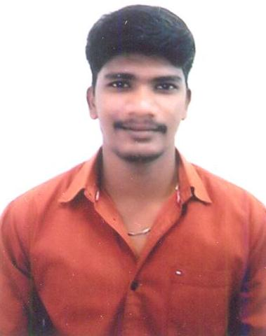
K.M.VINOTHKUMAR
Door No,102 Plot No,54&55
Ashok Nagar 2nd Bus Stop P M Palem
Visakhapatnam - 530041
Cell: 9551028053,9789586372.
E-mail:vinothkodali7@gmail.com

Career Objective:

Seeking a changing career with a progressive result oriented organization that offers ample opportunity to prove, improve and grow in career and professional advancement.

Qualification:

- B.SC.MATHEMATICS
Sir Theagaraya College, Chennai 2011-2014.

- HSC
E.L.M. Fabricius Hr. Sec School , Chennai.
Year of Passing : 2010-2011.

- SSLC
ST. Andrew’s High School Chennai.
Year of Passing : 2008-2009.

Experience:
- Worked as F&B Executive in Clarion Hotel For 4 Months.

- Worked as Executive in HDFC ERGO General Insurance For 2 months.

- Worked as DATA ENTRY CO-ORDINATOR For IMRB International from January 2015 To May 2017

- Working as Consultant in IKYA(Quess Corp Ltd) for KANTAR IMRB as Asst. Field Executive from May 2017 To June 2020

- Working as Relationship Manager in MARKET XCEL DATA MATRIX PVT LTD for July 2020 To Till to Date.

Computer Skills:

- Good Computer Knowledge
- Excel(Pivort Table ,Vlookup ,Etc.), MS Word & Power Point etc.
- Photoshop
- Data gathering using Internet

Personal Details:

Father : K.Mohanakrishnan
Date of birth : 29-04-1994
Nationality : Indian
Gender : Male
Marital Status : Married
Language known. : Tamil, English, Telugu
Hobbies : Playing Cricket, Music

Declaration:

I hereby declare that all the details furnished above are true and correct to the best of my knowledge and belief.

Place: Visakhapatnam Yours faithfully,

Date: K.M.VINOTHKUMAR

