**RESUME**

**SHANTHA KUMAR S,**

**S/O SELVARAJ,**

**11/138,Thengu,vilai,**

**Kallunatti,**

**Chitharal post,**

**Chitharal,**

**Kanyakumar District,**

**Tamilnadu,**

**Pin no:629151.**

**Email:**[*kumarsshantha6@gmail.com*](kumarsshantha6@gmail.com)

**Mobile No : +919787110920**

**Mobile No :+919489209005**

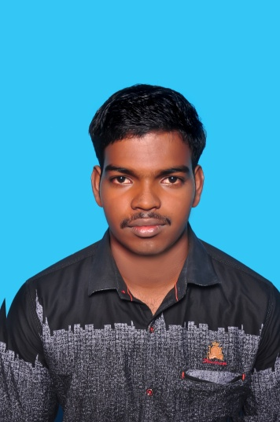

**Objective:**

To pursue a highly challenging career where I can apply my knowledge, acquire new skill and contribute constructively to the organization.

#### **Academic Details:**

|  |  |  |  |
| --- | --- | --- | --- |
| **Degree** | **Institution** | **Year of Passing** | **Percentage** |
| **Bcom with CA** | VTM college of Arts & Science Arumanai | 2016 | 57% |
| **HSC** | Aided higher secondary school Arumanai | 2012 | 57.16% |
| **SSLC** | Aided higher secondary school Arumanai | 2010 | 53% |

**Technical Skills:**

* Diploma Computer Hardware & Networking Engineering
* Diploma in Network Administration

### Personal Details:

**Name : SHANTHA KUMAR S**

Father’s Name : s/o SELVARAJ

Date of Birth : 06th OCTOBER 1994

Gender : Male

Nationality : Indian

Marital Status : Unmarried

Religion : Hindu

Caste : Nadar

Permanent Address : S/o SELVARAJ

11/138 Thenguvilai,

Kallunatti,

Chitharal post **,**

Chitharal,

K.K.Dist, pin code-629151

|  |  |
| --- | --- |
| TAMIL | ENGLISH |

Languages knowns :

**Declaration:**

I assure that the information furnished here is true to the best of my knowledge.

SIGNATURE :shanthakumar