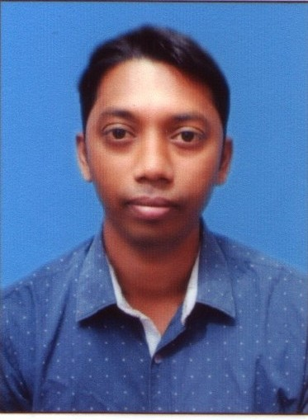 RESUME

**APPLY FOR THE POST OF**

**BIJOY KRISHNA ROY**

E-Mail ID: [papluroy300@gmail.com](mailto:papluroy300@gmail.com)

Mobile No – **7629095285**

|  |  |  |  |  |  |  |  |  |  |  |  |  |  |  |  |  |
| --- | --- | --- | --- | --- | --- | --- | --- | --- | --- | --- | --- | --- | --- | --- | --- | --- |
| OBJECTIVE : I am a person who always hopes high and also believes that, nothing is  Impossible for me if I work hard and give hard labour to my job. To be good in  any field the first thing that is required is dedication. I want to see myself in a  profession of any challenging sector as it attracts me the most due to its non-  Ending challenge and creativity.  PERSONAL  PROFILE : Father’s Name- Mr.Bikash Ranjan Roy  Date of Birth- 9th February 1986  Permanent Address- Durjoynagar, Agartala  Airport Road,  Near Holy cross School,  PO- Durjoynagar.  Agartala, Tripura (West)  Pin- 799009  Gender- Male  Marital Status- Married  Languages Known- English, Hindi and Bengali  QUALIFIATION:   |  |  |  |  | | --- | --- | --- | --- | | DISCIPLINE | SCHOOL/ UNIVERSITY | BOARD | YEAR | | Matriculation | East Durjoynagar High School | T.B.S.E | 2001 | | HS(+2 Stage) | SukhmoyHigher Secondary School | T.B.S.E | 2003 | | B.A | BirBikramMemorial College | Tripura University | 2007 |   ACADEMIC EXPERIENCE:-   * Soft Skills- A details study about the population, facilities-govt.and non govt. Organizations in Agartala.   EXTRA QUALIFICATION: - Microsoft Office., Tally ERP 9.  WORK EXPERIENCE:   * Worked at Joyram Agency (**A Distributor Of Nestle India Limited**.) As an Accountant in Agartala from June 2017 to Dec-2019.   **WORK NATURE**: 1. Billing Of All Order.  2. Maintaining All Cash Book.  3. Dealing With Retailer & Customer.  4. Preparing Daily Cash Sheet.  5. Co-ordinate with office staff & Other Official Work As Well.      WORK EXPERIENCE:   * Worked at United Drug Centre (**A Distributor Of Nestle India Ltd**.) As an Accountant in Agartala from April 2017 to May 2017.   **WORK NATURE**: 1. Maintaining All Cash Book.  2. Dealing With Retailer & Customer.  3. Preparing Daily Cash Sheet.  4. Co-ordinate with office staff & Other Official Work As Well.  WORK EXPERIENCE: Worked As a Data Entry Operator At RKD IT  Services from 9.12.2013 to 08.12.2014.  WORK EXPERIENCE:   * Worked at Sun-Plant Business Ltd As a Computer Operator cum Clerk From 2009 to 2013.   **WORK NATURE**: 1. Maintaining All Cash Book.  2. Preparing Daily Cash Sheet.  3. Other Official Work As Well.  EXTRA CURRICULAR  ACTIVITIES:   * Worked with an NGO as a volunteer. * Worked for old and homeless people.     Date:- 13/11/2019 ( Bijoy Krishna Roy) |