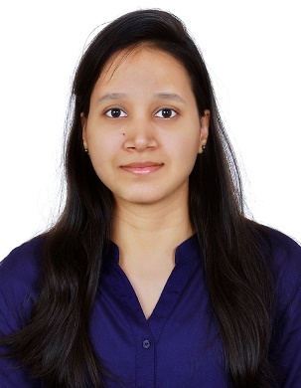 MAHIMA SUREKA

(+91) 8688063637

[mahimasureka2000@gmail.com](mailto:mahimasureka2000@gmail.com)

16-11-20, G-5, Bharani Apts, Saleem nagar colony,

Malakpet, Hyderabad, Telengana-500036

**CAREER OBJECTIVES**

To be a part of progressive organization to enhance my knowledge and utilize my skills towards the growth of the organization.

**ACADEMICS**

|  |  |  |  |  |
| --- | --- | --- | --- | --- |
| **Qualifications** | **Board/University** | **Institute name** | **Secured** | **Year** |
| B. Tech in EEE  (Pursuing) | JNTUH | Bhoj Reddy Engineering College  for Women | 7.736  GPA | 2017-2021 |
| XII | TSBIE | Sri Chaitanya Junior Kalasala | 96.7% | 2015-2017 |
| X | TSBSE | Ravindra Bharathi School | 9.0 GPA | 2014-2015 |

**TECHNICAL SKILLS**

* Familiar Electrical Software : MATLAB
* Programming Languages : Basic C
* Familiar with : Java, Python, IOT
* Others : MS Office.

**PROJECT**

* Working on: Power quality improved EV charger with Bridgeless Cuk converter.
* Study project: Electrical Accidents and Behavioral Safety.

**TRAINING**

* Advanced protection system of 132/33kv substation and introduction to SCADA smart grid.
* Designing of Solar Photovoltaic systems Conducted by Green Energy Technologies
* Workshop on Internet of Things (IOT) by Engineers Hub.
* Workshop on Python by Innovians Technology
* Attended Technology and career conference at BITS Pilani Hyderabad campus.

**ACHIEVEMENTS**

* + Won 2nd Price for paper presentation on Micro grids at Annual technical events
  + Awarded attendance certificate & scholarship for academic year 2017-18
  + Awarded Certificates for excellence in academic subjects in school.

**EXTRA AND CO-CURRICULAR ACTIVITY**

* + Runner up in Volleyball tournament at Annual sports and games event.
  + Participated in Volleyball tournaments at Inter college level and Regu events at Interdistrict level.
  + Awarded 1st prize in painting competition in school.

**PERSONAL DETAILS**

* Date of Birth : 08 June 2000
* Father’s Name : Pawan Kumar Sureka
* Mother’s Name : Rakhi Sureka
* Languages known : English, Hindi, Telugu
* Hobbies : Playing Volleyball, Learning new technologies.
* Gender : Female
* Nationality : Indian

**DECLARATION**

I hereby declare that all the above mentioned information is true and correct to the best of my knowledge.

# Place: Hyderabad MAHIMA SUREKA