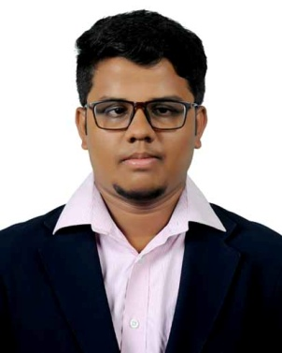

Dhanushvigneshwaran.P.C

Ph No : 9944770750

6379203767

E mail ID : prabhadvw@gmail.com

**CAREER OBJECTIVE**

To pursue a challenging career, where I can apply my existing knowledge, acquire new skills and contributes effectively to the organization.As well as I want to succeed in a stimulating and challenging environment that provide me with advancement oppurtunities.

**EDUCATIONAL** **QUALIFICATION**

|  |  |  |  |
| --- | --- | --- | --- |
| **DEGREE** | **NAME OF THE INSTITUTION** | **YEAR OF PASSING** | **PERCENTAGE** |
| B.Ed., | Sasurie college of education, Vijayamangalam | 2020 | Pursuing |
| B.Sc., MATHS | Sasurie college of arts and science , Vijayamangalam | 2018 | 63% |
| HSC | Kongu vellalar matriculation higher secondary school, Tirupur | 2015 | 60% |
| SSLC | Kongu vellalar matriculation higher secondary school, Tirupur | 2013 | 92% |

**LANGUAGES KNOWN**

* English ( R & W & S )
* Tamil ( R & W & S)
* Hindi ( R )

**CO-CURRICULAR ACTIVITIES**

* Awarded as a best coordinator award during the paper day celebration conducted by TIRUPUR ROTARY ELITE
* Won second prize in ppt @ SPECTRA’18.
* Won second prixe in quiz @ MATH BEEATz’18.
* Won second prize in quiz @ MAKEXCELS TALENT HUNT 2K18.
* Won first prize in test of knowledge @ ADINFINITUM (embracing knowledge).
* Won first prize in logo hunt @ RENEGADE-2K18.
* Won first prize in selfie contest @ COLLEGE DAY 2K17 & 2K18.
* Won first prize in ppt @ INTELLECTUS’18.
* Won second prize in tamil poetry competition @ INTERSCHOOL MEET.
* Won third prize in drawing competition @ INTERSCHOOL MEET.
* Won first prize @ AEE.BEE’S TALENT SEARCH.
* Won first prize in table tennis @ REBUPLIC DAY AND BHARATHIAR DAY ZONAL MEET.
* Won second prize in carrom @ REBUPLIC DAY SPORTS MEET.
* Won second prize in table tennis @ REBUPLIC DAY SPORTS MEET.

**HOBBIES**

* Reading books
* Listening to Music
* Writing Poetry
* Cooking and
* Travelling

**STRENGTH**

* Good team worker
* Flexibility of working hours
* Keen and affable
* Being punctual
* Dedicated person

**PERSONAL PROFILE**

FATHER’S NAME : Prabhakaran.R

MOTHER’S NAME : Chandra.S

NATIONALITY ; Indian.

ADDRESS : 3/1441, Vigneshwar illam,

Saravana nagar, serangadu,

Varanashipalayam north,

Kalipalayam panchayat, senapathy chettipalayam (po),

Tiruppur 641 666..

HOMETOWN :Trichy.

**DECLARATION**

I hereby declare that the information furnished above is true to the best of my knowledge and belief.

**SIGNATURE**