**SURESH KUMAR M**

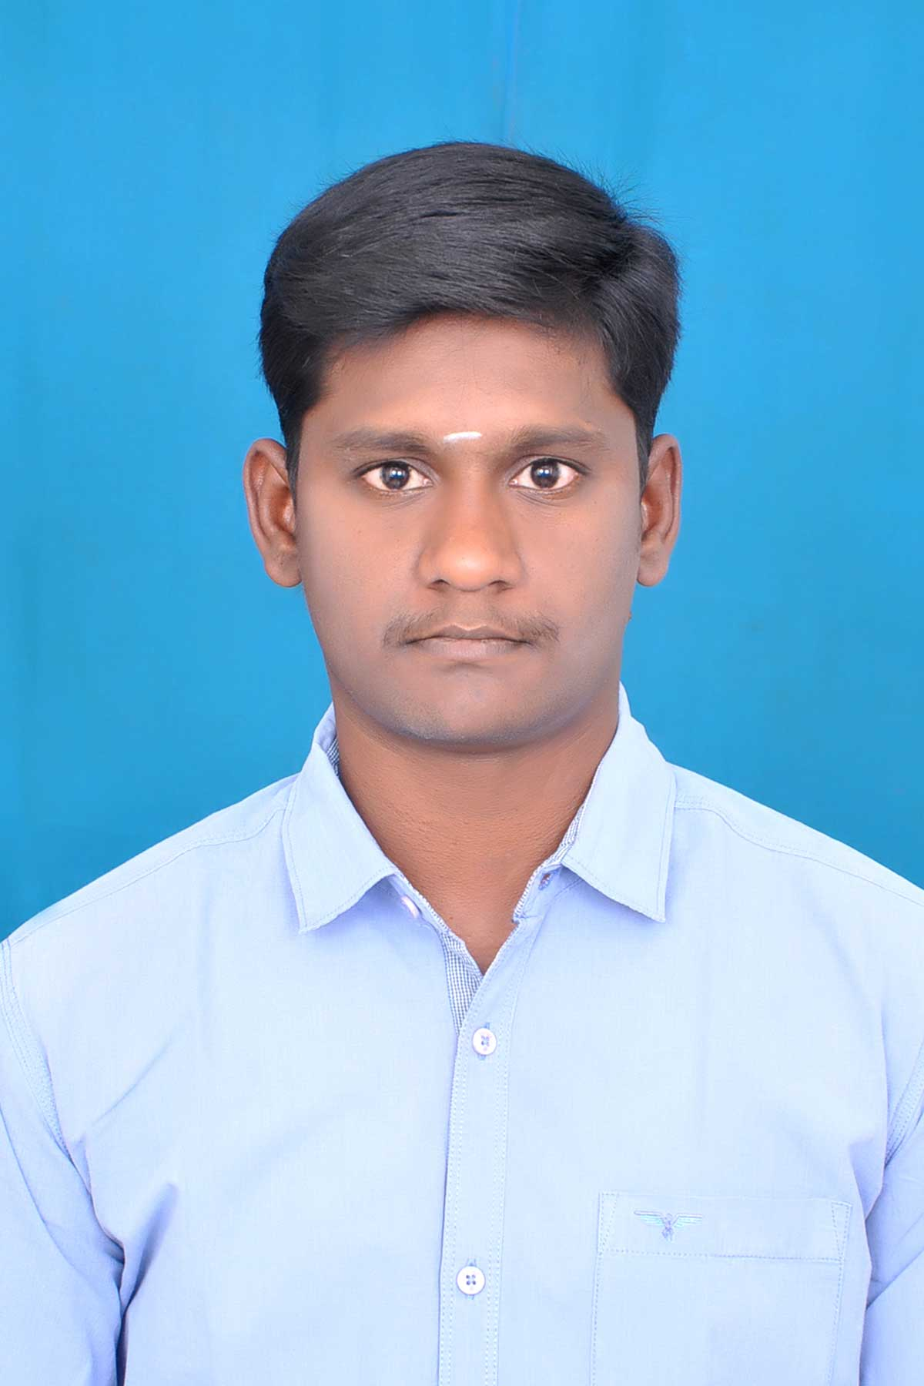

5/1204 E.B.QuartersChekkanur,

Navapatti(Post) Mettur(Taluk),

Salem(District)-636 452.

**Mobile**:+91 9943005337,8883364333

**E-mail**:sureshkumarm875@gmail.com

**CAREER OBJECTIVE**

Looking for a challenging career which demands the best of my professional ability in terms of technical and analytical skills,and helps me in broadening and enhancing my current skill and

Knowledge.

**ACADEMIC CREDENTIALS**

|  |  |  |  |  |
| --- | --- | --- | --- | --- |
| **Class/Course** | **Name of Institution** | **University/Board** | **Year of completion** | **CGPA/Percentage** |
| B.E  Electrical and  Elecrtonics  Engineering | Sri Krishna College of  Engineering and  Technology,Coimbatore. | Autonomous | 2017 | 6.58 |
| Diploma in EEE | The kavery  Polytechnic college  Mecheri. | State Board  (DOTE) | 2014 | 74.36 |
| SSLC | St.Mary’s Matric  Higher Secondary School  Mettur Dam. | Matric | 2011 | 48.8 |

**TECHNICAL SKILLS**

Simulation Software :Basic of Matlab,Labview,

**PROJECT**

TITLE : “PROTECTIONS OF PARALLEL TRANSMISSION LINE USING WI-FI”.

**ACHIEVEMENTS**

* District level winner in VOLLEY BALL match.
* Zonal level winner in SHORT PUT match.
* Participated in INNOVATION CHALLENGE conducted by Texas Instruments in SKCET.

**EXTRA AND CO-CURRICULAR ACTIVITIES**

* Coordinated college Symposium ‘EPIPHANY’ along with my team.

**INTERNAL PERSONAL SKILLS**

* Leadership good motivator and determined.
* Dedicated and punctual.

**EXPERIENCE**

One year experience in Electrical Maintances work in **UPDATER SERVICES PRIVATE LIMITED in olympia technology park site.**

**PERSONAL DETAILS**

Date of birth :September 22,1994

Language known :Tamil,English

Father’s Name :Muniappan.R

Mother’s Name :Tamil Arasi.M

Nationality :Indian

Permanent address :5/1204E.B. Quarters Chekkanur Navapatti(post)

Mettur(Taluk) Salem(district)-636452.

Hobbies :Playing Cricket and Volleyball.

**DECLARATION**

I here by declared that all the above mentioned informations are true to the best of my

Knowledge and belief.

**Place**:Mettur Dam

**Date**:

(Suresh kumar M)