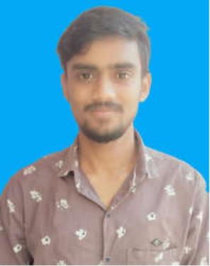
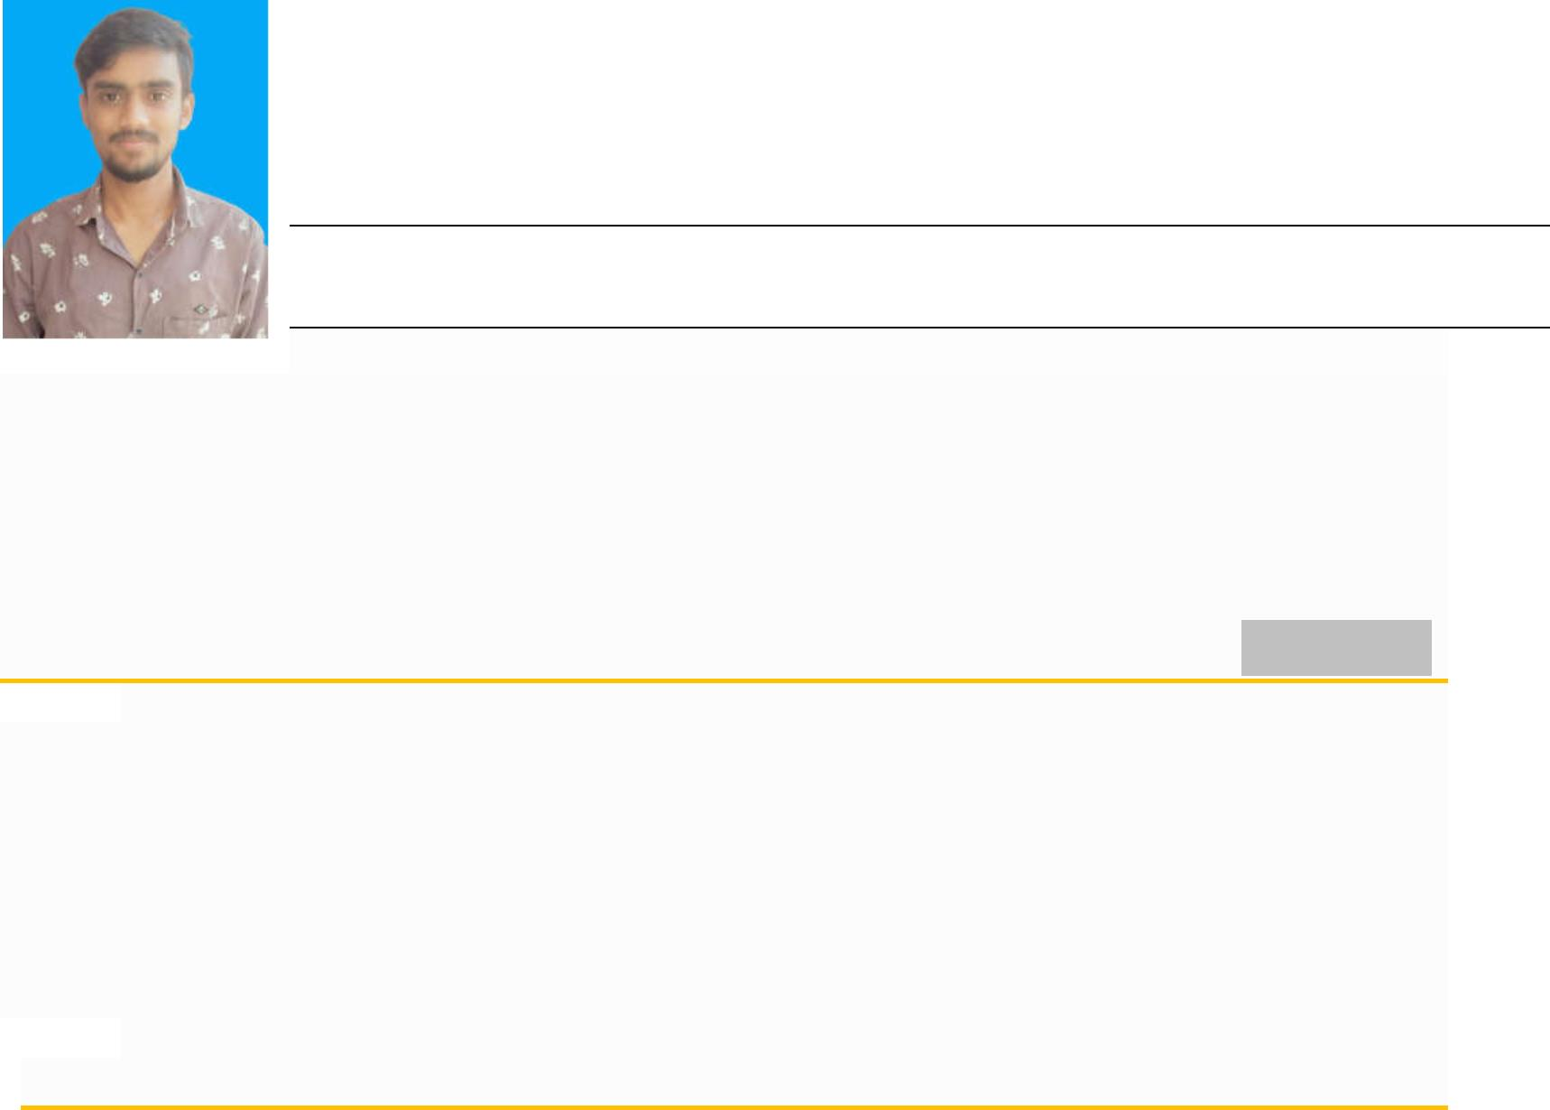
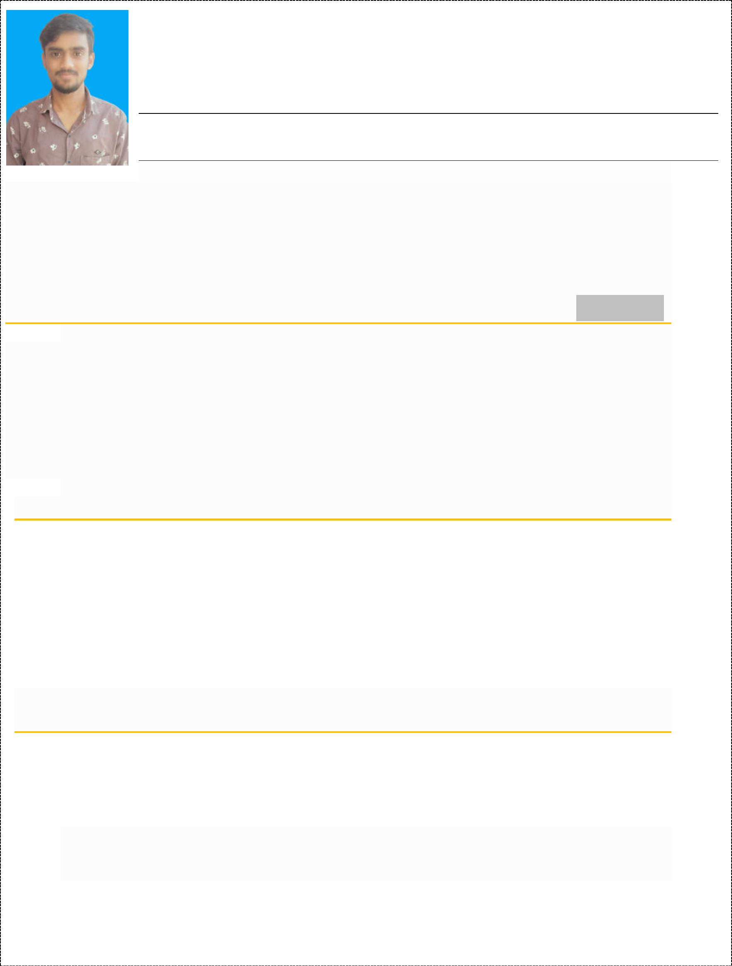
Mr. GOKUL VERMA
Vill- Muteda,Post-Dewaribhat, Dist.-Khairagarh, CG, India. Contact : +91-8085837514,
Email- gokulverma1001@gmail.com
Career Objective
Looking a position as system manager or corresponding label where I can utilize by technical skills
In manage to computerized network and resources. I can plan, co-ordinate with team and can also do
Direct computer related activities in an organization.
Work Experience
1+ Years
Civil Construction
TCS Academy Bhilai (1.6 Years)
Jun -2018 to Dec-2020
I’ve worked on various projects for the TCS Academy, and I work as a CAD DESIGNER and
CAD/CAM software like AutoCAD, 3D Civil architecture & 3Ds MAX with site projects, and also
working on design engineer for civil drawings and projects.
Certificate
• CAD (3Ds Max Design)
Jan -2021
Jan-2021
Dec-2020
2020-21
• CAD (3D Civil & Architecture )
• CAD ( 2D Drawing & 3D Modeling)
• Computer Science Engg (CSE)
•
•
•
Computer Hardware, Maintenace & Software Engineer
Web Development
Common Service Centre(CSC)
Dec 2019
July 2018
Govt. 2017
Education
• AutoCad and secured 90 % marks
• CSE (Diploma) and secured 60 % marks
AutoCad 2019-20
CSVTU 2019-20
CGBOARD 2016
CGBOARD 2014
th
st
• 12 with 2 Division and secured 52 % marks
th
st
• 10 with 2 Division and secured 49 % marks
Page 1 of 2


Skills
• Expert level knowledge of Windows OS, Window Server, Linux OS & knowledge of Mac OS.
• Active directory SQL Server , DBMS database, files & print server.
• Creating backup and safe guarding the data if there are any hindrances of pc’s, server and
database and perform system upgrades following new releases.
• System Security, Network security, firewall management & Antivirus management.
• Create and modify users, group and system partition.
• Overseeing System performance and troubleshooting issues.
rd
• Knowledge to manage 3 parties software like MS-office etc.
Personal Profile
st
• DOB
: 10 Jan-1998
• Father’s Name
• Nationality
• Marital
: Mr. Ram Jee
: Indian
: Singal
• Gender
: Male
• Language known
: Hindi & English
•
Interest
: Internet surfing , Cricket and Music
I hereby declare that the above mentioned all information is correct and true to the best of my knowledge.
Place: Khairagarh
Gokul Verma
Date: ---/---/2021
Page 2 of 2

