**RESUME**

Name: M. Sohail Umar Ansari 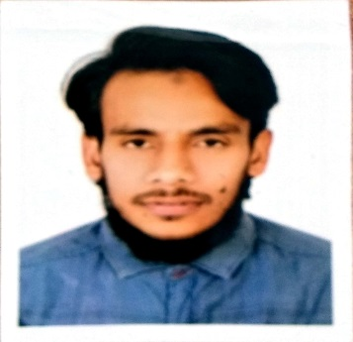

Date of Birth: 06th April 1995

Mobile No: +91 9595859063

Email-Id: omarbinsohail1011@gmail.com

Postal Address: Near Kolsatal Masjid Kamptee-441002 Nagpur

# **CAREER OBJECTIVE**

To work with maximum potential in IT sectors to enhance professional skills by learning new technologies and utilizing my expertise for self, career and organizational growth

**ACADEMIC QUALIFICATION**

|  |  |  |  |  |
| --- | --- | --- | --- | --- |
| QUALIFICATION | INSTITUTE | UNIVERSITY | YEAR OF PASSING | DIVISION |
| BSc-IT | S.K.P College | Nagpur University | 2015 | IInd |
| HSC | M.M.Rabbani Jr College | Nagpur Div.Board | 2012 | IInd |
| SSC | M.M.Rabbani High school | Nagpur Div.Board | 2010 | Ist |

**COMPUTER PROFICIENCY**

* Diploma in MSC-IT, POWER POINT
* Command in ERP (Enterprise Resources Planning ) System
* Windows 7, Excel , MS Office, and well versed with Data Application

**WORK EXPERIENCE**

* Working with SANDAN PRIVATE LIMITED as a STOOR KEEPER form last 19 months.
* Since last 6 months working as MATERIAL CONTROLLER(our material controller is on vacation since march due to corona he cannot come yet )

**STRENGTHS**

* Team Leader and Target Achiever potential
* Quick learner and Application Oriented
* Effective Time and Resource Management
* Responsible and focused for Task Assigned
* c

## achievements and Honours

* I was awarded as the best captain of my college Football team
* Represented Dr. B C Roy Trophy Jr. National Football Tournament at Silli Guri in 2012-13
* Represented Inter-University Football Tournament at Gwalior in 2014-15
* Represented U-19 State Level Football Tournament at Yevatmal in 2012-13
* Represented U-17 State Level Football Tournament at Kolhapur in 2010-11
* Represented U-17 State Level Football Tournament at Mumbai in 2010-11

**PERSONAL DETAILS**

Father’s Name : Mohammad Umar Ansari

Mother’s Name : Rehana Begum

Date Of Birth : 06th April 1995

Nationality : Indian

Gender : Male

Marital Status : Single

Height : 174 cm

Weight : 74 Kg

Languages Known : English, Hindi and Urdu

I hereby acknowledge that the information furnished above is correct to the best of my knowledge

DATE:

PLACE:  **(**M .SOHAIL ANSARI)