CURRICULUM-VITAE

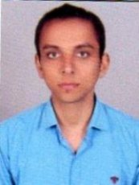
DEEPAK TIWARI
Address:
B-9/1, Sarvodaya Nagar, Lucknow
Pin code : - 226016
Contact No. 9984911777
Email: Dtiwari11092@gmail.com

Career Objective:

By acquiring knowledge, expertise and a familiarity with the organization’s culture, I want to contribute towards realizing organization’s vision and become its integral part.

Educational Qualification:

S No. Qualification Board/University Year
1 High School CBSE 2009
2 Intermediate CBSE 2011
3 Graduation (B.com) Awadh University 2014

Computer

:

- CCA(Certificate in computer accounting)
- Tally.

Work Experience:

- One year work in INDUS Towers ltd.
- One year work in Logistic Co.In Delhivery.

- Three year work in AMAZON.IN

- I am working in Big Basket.Com

Personal Details

Father's Name : Mr.Rajendra Prakash Tiwari
DOB : 28 May 1994
Gender : Male
Languages Known : Hindi & English
Address : B-9/1 Sarvodaya Nagar Lucknow

Declaration:

I hereby solemnly declare that all the statements made in the above application are true to the best of my knowledge and belief

DATE:

SINGNATURE: (Deepak Tiwari)

