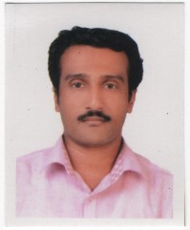
Anoop B
Vettoorpurayidam
Thekkethukavala PO
Ponkunam, Kottayam
Pin 686519
Mob – 9995124993
Email: anooppnkm@gmail.com

Career Objective:
To become professional by which I may put my expertise best for the satisfaction and development of the organization and thereby improving my knowledge and skills for higher tasks.
Academic Chronicle:
Course | Institution | University | Result
MSc Computer Engineering &Network Technology | School of Technology & Applied Science | M G university | First Class
BSc Electronics | MES College | M G university | First Class
PDC | SVRNSS College | M G university | Third Class
S S L C | SVR NSS HS | Board of Public Examination | First Class

Experience:
4 year and 8 months experience in Omshree Sidha Hospital as Admin and Digital/Social Media Marketing Executive
2 year of experience in the Tourism India Publications as Sub Editor.
1 year and 6 months of experience in Labor India Publication as Editorial Assistant in computer science.
1-year experience in Libsoft Solutions as Office Executive.
2 years as Business Development executive in Reliance Communications.

Personal Information:
Date of Birth | : | 17-03-1982
Gender | : | Male
Languages Known | : | Malayalam, English
Hobbies | : | Browsing, Listening Music, TV Watching

Declaration:
I hereby declare that the information furnished above is true to the best of my knowledge. I assure my service to your organization may be made remarkable by best use of my knowledge and caliber.

Date: 05-08-2020 Anoop.B

