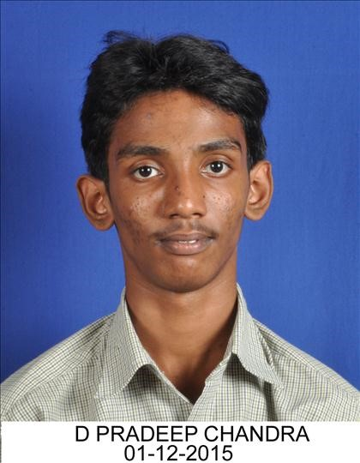DOKUBURRA PRADEEP CHANDRA | 16MI33006

MINING ENGINEERING SAFETY ENGG. (M.Tech Dual 5Y)

|  |  |  |
| --- | --- | --- |
|  | EDUCATION |  |
| Year | Degree/Exam Institute | CGPA/Marks |
| 2021 | M.TECH Dual Degree 5Y IIT Kharagpur | 7.68 / 10 |
| 2016 | Intermediate Public Examination (IPE) AP State board of Intermediate Education | 96.6% |
| 2014 | Secondary School Certificate Board of Secondary Education,Andhra Pradesh Examination(SSC) | 9.2 / 10 |
|  | COURSEWORK INFORMATION |  |

Programing and data structures, Probability and statistics, Machine Learning by Andrew ng, Linear algebra, Solid

Mechanics, Rock Mechanics, Basic Electronics, Educational Neuro Science, Mining Machinery, Ventilation and

Climate control, Ecnomics of Mining Enterprises, Mine Hazards and Human Rescue, Surface Mining

# PROJECTS

**Students awareness of learning styles and their perceptions to a mixed method approach for learning(Demographic Learning Style Analysis)Under Prof.Raja Lakshmi Guha(Centre for educational technology department)**

**Status of the project : Completed**

The way we learn is subjective and individuals have modality preferences.

The purpose of this study is to make a simple comparison between various social groups based on their demography.

To test if the upbringing (location), education status (IIT/Non IIT), gender has any effect on the way a person learns better or choses to learn.

**Eye Movements During Everyday Behavior Predict Personality Traits using Machine learning and Artificial intelligence algorithm Under Prof.Jhareshwar Maiti(Industrial And Syestems Engineering department)**

**Status of the project : ongoing**

One key contribution of our work is to demonstrate, for the first time, that an individual’s level of neuroticism, extraversion, agreeableness, conscientiousness, and perceptual curiosity can be predicted only from eye movements recorded during an everyday task

And we need to prepare questionaire comprising 60 questions assessing neuroticism, extraversion, openness, agreeableness, and conscientiousness Classifier performance was evaluated in terms of average F1 score across the three score ranges. The F1 score for a particular range R is defined as the harmonic mean of precision.

The proposed machine learning approach was particularly successful in predicting levels of agreeableness, conscientiousness, extraversion, and perceptual curiosity and later on the predicted values were verfied using random forest classifier algorithms

# SKILLS AND EXPERTISE

**Programming languages** **:** C , C++ , Python , MatLab , Octave

**Skills** **:** Autocad , MS office , MS excel

**Operating Platforms :** Windows 10 , Linux , Unix

**Software(s) Used :** Python 3.7, Jupyter Notebooks , Octave 4.0.1, Matlab online 2019a

CERTIFICATIONS

Courses and workshops

!self declaration by the student

Machine learning course offered by Coursera and instructor Andrew Ng

Attended the Artificial intelligence Work Ship Conducted by the Edufabrica 2018 in IIT kharagpur

# EXTRA CURRICULAR ACTIVITIES

Represented my hall in the **Inter Hall Volleyball,Cricket and Squash** in **2017** and **2018**

Represented my hall in the **Inter Hall Maths Olympaid and AD design in 2017**

|  |  |
| --- | --- |
| POSITIONS OF RESPONSIBILITY | |
| Position of Responsibilities |  |

Worked as a Joint Secretary for sports and games in JCB hall of Residence in period of 2017 - 2018

Worked as a Crew member of Great step,IIT Kharagpur conducted by Mining engineering department in year 2016

Became a **Captain** of JCB inter hall Squash Captain in **2018**

!self declaration by the student