**RESUME**

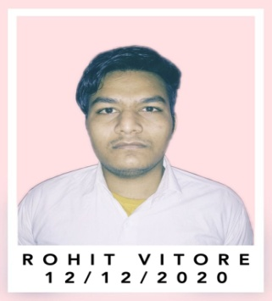Name : **ROHIT VITORE**

DOB : 14/05/1997

Address : Anna Nagar Govindpura Bhopal (M.P.)

Contact No : +91 8770903045  
E-Mail : [rohitvitore@gmail.com](mailto:rohitvitore@gmail.com)

Nationality : INDIAN

**CAREER OBJECTIVE**

* Looking forward to work with **Manufacturing Company** and wants to pursue in **Research & Developement Department** to develope efficient and economically products for the company.

**BASIC ACADEMIC CREDENTIALS**

|  |  |  |  |
| --- | --- | --- | --- |
| **Education** | **Board/University** | **Year** | **Percentage/CGPA** |
| Bachelor of Engg.(Mechanical) | Ragiv Gandhi Proudyogiki Vishwavidyalaya | 2019 | 78.60% |
| 12th | Madhya Pradesh Board of Secondry Education | 2015 | 71.56% |
| 10th | Madhya Pradesh Board of Secondry Education | 2013 | 81.66% |

**PROJECTS**

* Developed a simple **Robotryst -2016.**
* Developed a **Biogas Plant prototype,** consists with small cylinder attached with a tube which fills up by the process of anaerobic digestion of biodegradable materials.
* Majour Project : Thermal solar dryer for agriculture products

**CAMPUS SELECTION**

Pacific Gears

Add.: ahmedabad gujrat

**EXPERIENCE**

* 6 Months in pacific gears Ahmedabad GJ (2019)
* 2 Months in RKTC Bhopal (2021)

**IT PROFICIENCY**

* **Operating system:-** Windows 7/8/10
* **Office:-** MS office
* **Designing:-** AUTO CAD

**HOBBIES &INTEREST**

* Used to watch Technology movies, visiting historical places, playing chess, & Cricket.
* Visiting Production Industries to gain practical knowledge of manufacturing field.

**DECLARATION :-**

**I hereby declare that the above furnished information is true to the best of my knowledge and that I will be held responsible for any deviation from them at a later stage.**

**Place: BHOPAL (Rohit Vitore)**

Date: **Signature**