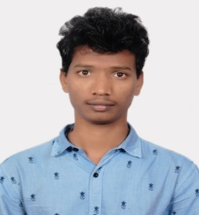
SERUPALY RAKESH
Gayathrinagar, near VishwaVikas high school,
Nizamabad, Telangana, 503001.
raki.pally@gmail.com, 8465071374.
I am very much interested in developing my skills and learning new things and yours is the correct platform to showcase my talent.

Experience

JAN, 2021 – april, 2021

installation, zuva engg. pvt ltd.
Site Engineer & Supervisor for 100kw Solar Roof Top Power Plant at VISAKA Industries Kukkadam.

nov, 2020 – jan, 2021

operation & maintenance, AGI glaspac bhongir.
Technician & Supervisor for 8.5Mw Solar Power Plant.

may,2018 – jun, 2018

study of turbo generators, BHEl Hyderabad.
Study & Observed the Assembly process of Generators.

dec, 2015 – may, 2016

study & observation of 132/11kv sub station, ts trans-co, kosli, fakirabad.
Study & Observed the Operation & Maintenance of Sub Station.

Education

april ,2019

b-tech, bharat institute of engg & tech.
67.6% in Electrical and Electronics Engg.

march, 2016

diploma, vijay rural engg college.
76.7% in Electrical and Electronics Engg.

april, 2013

ssc, sri vishwashanthi high school.
6.5CGPA.

Skills
- House wiring
- MS Office

Activities
- Participated in JNTUH HACKATHON workshop
- Organised college events
- Online Certified course in Low voltage circuit breaker Design.

