**Name-Bharat Pal**

**Permanent Address: - Gali no.-2 Shalimar Garden, Behat Road Saharanpur 247001.**

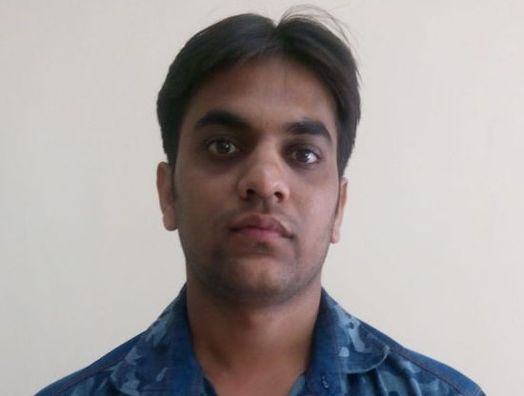

**Date of Birth:- 06-10-1998**

**Contact No: - -7017008709**

**E-mail: -- palbharat96@gmail.com**

**Career Objective**

To work in an Organization that provides a challenging and stimulating work environment where I can realize my potential to the fullest.

**ACADEMIC QUALIFICATIONS**

|  |  |  |  |
| --- | --- | --- | --- |
| **Year** | **Examination** | **Board/University** | **Percentage** |
| 2018 | B.Com | C.C.S.U | 61 |
| 2015 | XIITH | C.B.S.E | 69 |
| 2013 | XTH | C.B.S.E | 72 |

**PROFESSIONAL EXPERIENCE**

|  |  |
| --- | --- |
| **Organization :**  **Department :** | **INDIAN OIL CORPORATION LIMITED** (From 08.01.2019 to 07.01.2020)  FINANCE & ACCOUNTS. |
| **Designation :** | Accounts Apprentice  Areas Worked in:   * Assist in processing bills of Clearing and Forwarding Agents (CFAs) * Assist in payment of Various Lubes Schemes in Indian Oil. * Assist in monitoring of outstanding of BRO Customers. * Assist in preparing of various MIS, like Ageing of BRO Customers * Assist in preparing liability in SAP. * Assist in Processing of Ethanol Bills payment. |

|  |
| --- |
| **EXTRA CURRICULARS** |

* District level Hockey Player.
* District Level Volleyball Player

**COMPUTER EXPOSURE**

* Certificate Course in Computer Concepts.
* Practical experience in S.A.P ERP **R/3.**
* Conversant in MS Office & Windows.
* Familiar with Internet Operations.

**STRENGTHS**

* Strong communication, interpersonal, learning and organizing skills
* Enjoy Working with Team and Open to Ideas.
* Achievement oriented with an ability to manage change with ease.
* Proven strength in problem solving, coordination and financial analysis.
* Ability to manage time and people effectively

**Hobbies and Interest**

* Listening to music, socializing with family and friends.
* Playing Hockey.

**PERSONAL DETAILS**

|  |  |
| --- | --- |
| Father's Name | - Sh. Satish Kumar |
| Mother's Name | - Smt. Rama |
| Date of Birth  Nationality  Languages Known  Marital Status | - 06/10/1998  - Indian  - Hindi/English  - Single |

DATE: __/__/_____ PLACE**: Saharanpur**

(Bharat Pal)