8376860634 akashyadavkit@gmail.com

**Education**

|  |  |  |  |
| --- | --- | --- | --- |
| **College/Board** | **Year** | **Certification** | **CGPA/%** |
| RICS, Noida | 2016-18 | MBA- Constructions  Project Management | 7.38 CGPA |
| Kumaon Engineering College (Govt.) | 2011-15 | B. Tech Civil Engineering | 74.70 % |
| CBSE | 2010 | XII | 76.67% |
| CBSE | 2008 | X | 83.20% |

**Skills**

* MS Office,
* Autocad 2D
* Autocad Revit
* Primavera P6
* MS Project
* Good Presentation Skills
* Communication Skills
* Team Dynamics, And
* Smart Worker

**Concepts**

* Cost Management, Project Management
* Earned Value Management (EVM)
* Vendor Management
* Project Cost Controls
* Value Engineering
* 5D Costing
* Quantity Take-Off

**Achievements**

* Part of Successful Bidding Team of Civil Package 4, NCRTC (1126 Cr).
* Part of Successful Bidding Team of MEP Package 1, MMRC (200 Cr.).

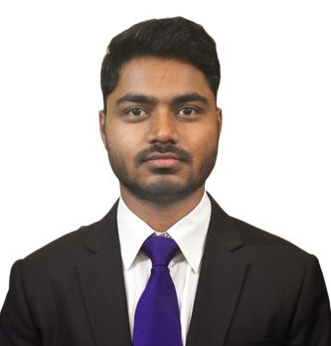**Akash Yadav**

**Project Costing and Control**

**Work Experience**

**Shanghai Urban Construction Group Infrastructures, India (SUCGI)**

**July 2018 - Till Now**

**ENGINEER**

* Working in Costing, Budgeting, Tendering & Planning Cell.

**Project Cost Report**

* Responsible for preparation of quarterly tunnel cost report for CC126, DMRC project for SUCGI subcontract.

**Quotation Collection and Analysis**

* Pre-bid project costing (₹**1126 Cr**) of high speed rail package 4, NCRTC.
* Responsible for vendor and subcontractor analysis of **Pune Metro** UGC-01 & UGC-02 (Civil Package) project of **₹ 1100 Cr +.**
* Worked in technical documentation & analysis of **Mumbai Metro** MEP package Phase 1 and Phase 2 projects of **₹ 200 Cr + each**.

**Planning, Contract, Costing and Vendor Management**

• Part of **successful** bidding team of civil underground **high speed rail**, **Package 4, NCRTC (1126 Cr).**

• Part of team responsible for **pre-bid costing** of Delhi Metro (₹**110 Cr**), Pune Metro (₹**1100 Cr+)** and Mumbai Metro **(₹200 Cr+**) Projects.

• Part of ongoing project of **Delhi Metro CC126 (₹ 335 Cr**) project cost team for the project via.

• Analysed L1 vendor for rate finalisation.

* Conducted meetings with both **international and domestic vendors**. Clarified the project requirement and got the **10 -15 % reduced prices** from initial offer vendors.

**Subcontractor Documents Preparation**

* Worked in Priority Sewer Tunnel project of **Municipal Corporation of Greater Mumbai (MCGM)** of **₹ 700 Cr +** project for financial bid preparation and subcontractor registration.

**Tender submission**

* Submitted both offline submission for Mumbai Metro and online submission of Package 4, NCRCT and Delhi Metro CE 23 project.

**BIM implementation**

* Working in Building information modelling team for **BIM implementation** in the organization for upcoming tenders.
* Acquiring knowledge for understanding BIM tools and processes for implementation on projects as per the requirement of prime contractor

**Personal Snapshot**

* Date of Birth : 28th Feb 1993
* Guardian’s Name : Omprakash Yadav
* Languages Known **: Fluent in** English and Hindi