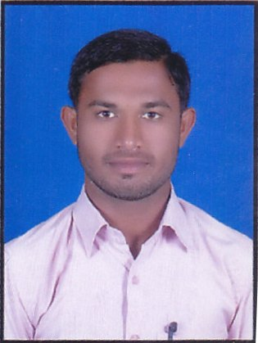
Resume
Name Umar kalim khan
Add Qureshi Nagar Texi Stand Kurla(East)
Mumbai pin code 400070
Stust Maharastra (India)
Email ID umarkhan143001@gmail.com
umarkhan143002@gmail.com
Mobile - +918698786328
+918830098442

Objectives

Aspire to be a part of a value adding team of an organization. Believe strongly in the concept of work through positive motivation. Career planning of consist of effective implementation of task and responsibility.

Educational Qualification

EDUCATION | UNIVERSITY/BOAD | Year of Passing | PERCENTAGE
H.S.C (since) | Nasik Board | Feb 2015 | 60.59%
S.S.C. | Nasik Board | March 2013 | 53.00%
SCNA (Diploma) | Silicon valley (jalgaon) | 2016/17 | Complete

Professional Qualification

- Complete in Cisco Certified Network Associate.
- SCNA Diploma from Silicon Valley, Jalgaon

Experience

• Central Bank of India c.b.d Belapur Mumbai Hardware.+ Network.+ Desktop Suppor Engineer 1th year 6th manth Experience ( 2019-2020-2021 )

Key Skills
SCNA Diploma

Technical Skills
- Hardware (A+) : Computer Architecture, Types of Memory, Assembling, De-assembling, Troubleshooting, Formatting, Partitioning, etc.
- O.S. Installation: Installation of WindowsXP, Windows7, Windows8, Windows8.1.
- Networking (N+) : Networking Concepts, Types of Networks, Network Topology, OSI models, Area Networks, TCP/IP protocol suite (IP, TCP, UDP, FTP), IP addressing and sub-netting, Routing concepts
- CCNA : Good knowledge of Routers, Switches and firewalls, Configuration, verification & troubleshooting basic router operations & and routing on CISCO Devices.

personal Information

Name | Umar kalim khan
Fathers Name | Kalim bismilla khan
Date of Birth | 13/08/1996
Gender | Male
Marital Status | Unmarried.
Languages known | English, Hindi, Marathi,
Permanent Address | At. Post Antutrali kh. Tel.pachora Dist.Jalgaon
Contact (M) | +918698786328 +918830098442
E-mail ID | umarkhan143001@gmail.com  umarkhan143002@gmail.com

I, Umar khan, declare that the above furnished information is true and correct to the best of my knowledge.

Date : Signature,

Place : Umar Khan

