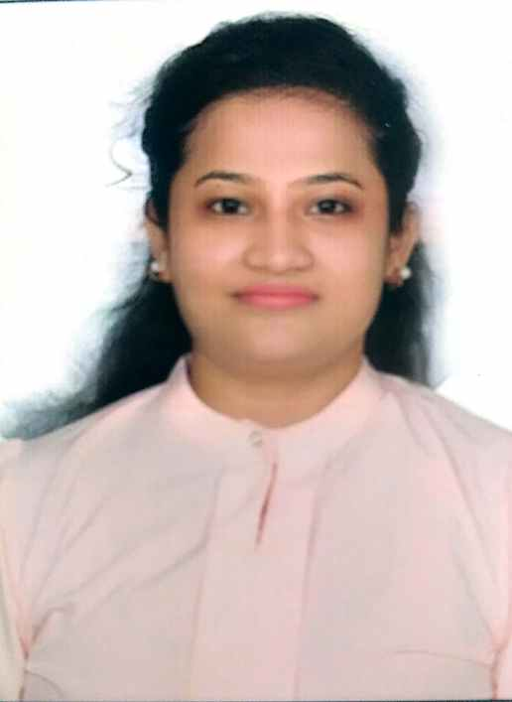

***In quest of challenging assignments in financial sector with a growth oriented reputed organization***

**Work Experience**

* Currently working in **AIR INDIA AIRPORTSERVICES LTD**, **Mumbai** as **JE HR ADMIN.(Since-Nov 2019)**

Reporting to Human Resource Head & Sr. AGM of department. Document Verification, Collection of copies of documents, Generating and Signing of Agreement and application for access cards, Sending Manpower details & training details, looking over all the administrative requirements. Issuing Of warning letters. Working mainly on excel forreports.

* **01 YEAR**: Worked in **Sutherland, Mumbai** as **Senior Specialist** under **HR shared Services. (Sep 18 to Sep 19)**.

Reporting to Team Manager. Worked on Oracle People Soft Tool, Oracle Fusion Tool, Service Now Tool, Background Verification, HRIS, Certificate of Employment, Leave Management, SOPs, Employee Query Resolution Grievance Handling and Performance Appraisal Assistance.

* **01 Month**: Worked in **88 Pictures Media Pvt Ltd** as Trainee HR.

Short listing of resume & calling for interview. Reporting to Human Resource Head. Pre-Joining and Post-joining formalities, employee code generation. HRMS, Document Verification, Collection of copies of documents, Generating and Signing of Agreement, and application for access cards.

* **01 Year**: Worked in **Akashvani Lucknow** as an **Anchor** in Yuvani Section in 2014.
* **02 Years:** Worked as **JUNIOR OFFICER**, in **CAN FIN HOMESLTD** sponsored **Canara Bank**, Lucknow. (**Sep 14 to Aug 16)**. Dealt in Credit Department. Handled accounts, bank reconciliation statement, home loan property inspection and disbursement, customer dealing.

**Academic Details**

|  |  |  |
| --- | --- | --- |
| **Year** | **Institution** | **Grade** |
| 2018 | Nursery Teachers Training, NCERT Recognised, Karwar, Karnataka | 77% |
| 2014 | Radio RJ course from Akashvani Lucknow |  |
| 2012 | MBA (HR & IR) from Lucknow University, Lucknow | 71% |
| 2009 | B.Tech. (CS) from College of Engineering Sciences & Technology, Lucknow | 75.42% |
| 2005 | Class 12th from Rani Laxmi Bai Senior Secondary School, Lucknow (CBSE) | 65% |
| 2003 | Class 10th from City Montessori School, Lucknow (I.C.S.E) | 75% |

**Internship at Tata Motors**

***The Current Practices & Desired Status of Rewards & Recognition***

**Summary**

* Studied the current HR practices in Rewards & Recognitions segment implemented by the company.
* Conducted surveys & in-depth interviews of senior employees to gather information on employee perception.
* Identified need gaps in the segment with recommendations to resonate with employees expectation.

**Academic Achievements**

* Attended Conference on REVIVAL OF INDUSTRAIL RELATIONS IN INDAI at XLRI Jamshedpur in Jan 2012.
* Industrial trainings during engineering
* Bharat Sanchar Nigam Ltd, 2007
* Training concerned with the principles & techniques involved with GSM communication & latest advancements.
* Hindustan Aeronautics Ltd, 2008
* Training concerned with Lean Management - An efficient business system for organizing & managing product development, operations, suppliers & customer relations.

**Areas of Study**

* Essentials of management, Human Resource Management, Indian Value system & Business Ethics, Marketing Management, Business Law, Industrial Relations, Computer applications & MIS.

**Industrial visit - Rudrapur (Feb 2012)**

* Parle Biscuits Pvt. Ltd., Pantnagar
* Britannia Industries Ltd.
* Perfetti Van Melle India Pvt Ltd
* APC Inverters.

**Positions of Responsibility**

* Member of Event Organizing Committee, IMS LU, 2010-12.
* Successfully organized & participated in the Blood Donation Camps, 2008-09.
* Student Coordinator, Literary Society, Rani Laxmi Bai Inter College, 2004-05.
* Member of Cultural Committee, Rani Laxmi Bai Inter College, 2004-05

**Honours and Awards**

* Stood First in RADIO LBS, a RJ HUNT organized by LAL BADUR SHASTRI INSTITUTE (LBS), Lucknow.
* Stood First in SUR PAHELI contest, a Bollywood Quiz organized by LBS, Lucknow.
* Finalist, Business Baazigar - An event of strategic planning & business management, IMS LU, 2011
* Certificate of Special Effort - Cancer Aid Society, 2004.
* Passed UN INFORMATION TEST conducted by United Schools Organisation (a wing of UNO), 2003.
* HT Knowledge Index Quiz Contest, 2003-04.
* Certificate of Merit - Prestigious GK Contest, 2001.
* Intra School Bournvita Quiz Contest, 2000-01.

**Extra-Curricular Activities**

* Acted and directed plays staged at IMS LU & other colleges and for community service, 2010-12.
* Won prizes in Group Discussion, Debate & Extempore Competitions at School and College.
* Member of Badminton, Cricket & Kho-Kho teams at School and College.

**Core Technical Expertise**

Applications : Access, Excel, Power Point, Word, C/C++ programming.

Operating Systems : Windows 9X/ 2000/ NT, XP.

**Personal Details**

Date of Birth : 19/09/1988

Father's Name : R C NIGAM

Mother's Name : Shail Nigam

Husband's Name : Lt Cdr Ashish Srivastav

Linguistic proficiency : English, Hindi

Primary Skills : Credit and Loaning, Inspection, Rewards and Recognition programs, Performance Appraisal and Industrial Laws.

Hobbies : Badminton, Swimming