House#439,

Sector-19, Mandi Harzi Ram, Malout

Punjab.

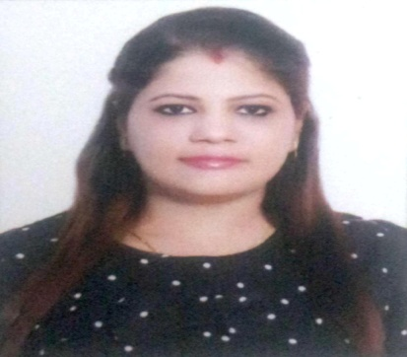

HARSHIKA SHARMA

+91 9667106772

Harshikasharma18@gmail.com

OBJECTIVE



To take responsibility that provides a challenging and friendly environment with an equal blend of systems and applications, in order so as to contribute fruitfully and try to be an asset to the organization.

EMPLOYMENT HISTORY



**06/2017 – 08/2018 Assistant to the Sr. Project Manager Transemirates Contracting LLC**

**Al Zarooni Group of Company, Dubai, UAE**

* Assist the Sr. Project Manager and other Engineers.
* Maintain records of the Sr.Project Engineer and assists in their movements.
* Received and release submittals to Consultant & Sub-contractors.
* Sorting and distributing incoming post, organizing and sending outgoing post.
* Maintaining Filing system and Drawings.
* Take minutes of meetings and maintains records for the operations and project team.
* Managing and updating data base in a day to day basis.
* Preparing correspondences.

**06/2015 - 10/2016 Academic Counselor**  **International Women Polytechnic, New Delhi**

* Looking into admissions and providing guidance to Students in taking right stream for a bright future in India or abroad
* Looking after the administration functions including Fee Structures, collections and so on.
* Handling Projects on Education awareness conducted by the College.

|  |  |  |
| --- | --- | --- |
| **03/2014 - 03/2015** | **Business Development** | **Shri. Events Group Pvt. Ltd, New Delhi** |
|  | **Executive** |  |

* Identifying new sales leads
* Doing quotation in Excel and making detailed programs wherever required.
* Looking after day to day operations of the Events happening.
* Contacting potential clients via email or phone to establish rapport and set up meetings.
* Negotiating rates with Hotels.

**02/2013 - 08/2013 Administration Executive Bimal Water Solutions, New Delhi**

* Coordinating between departments and operating units in resolving day-to-day administrative and operational problems
* Scheduling and coordinating meetings, interviews, events and other similar activities.
* Sending out and receiving mails and packages
* Managing documents and files
* Managing mailing or distribution lists as needed
* Researching of vendor prices or inquiring about participants' availability.
* Recording the minutes of meetings of Employees.
* Maintaining the records of invoices, expenses, charge cards and petty cash.
* Assisting in various daily operations

**07/2011 – 12/2012 Domestic Reservation Executive Atlanta travels Pvt.Ltd., New Delhi**

* Arranging reservations and routings for passenger on request.
* Planning routing and computing ticket cost.
* Telephoning Customers to confirm the final status of the Reservation

EDUCATION HISTORY



|  |  |  |  |  |
| --- | --- | --- | --- | --- |
| **03/2012** | | **Delhi University** | | **Arts, Bachelor's Degree** |
| **07/2009** | | **D.A.V Centenary Public School, Noida** | | **Commerce** |
|  | |  |  |  |
| **05/2007** | | **Sarvodaya Girls Sr Sec School, Kiran vihar** | | **High School** |
| CERTIFICATIONS & HONORS | | |  |  |
|  |  | | |  |
| **2014-2015** | **Diploma in Nursery Primary Teacher Training** | | | **International Women Polytechnic College, New Delhi** |
| **2010-2011** | **Diploma in Travel & Tourism Management** | | | **Mata Sundari College. Delhi University, New Delhi, India** |
| **2010-2011** | **Certificate in Computerized Reservation System** | | | **Mata Sundari College, Delhi University, New Delhi, India** |
| **2009-2010** | **Certificate in Travel & Tourism Management** | | | **Mata Sundari College, Delhi University, New Delhi, India** |
|  |  | |  |  |
| SKILLS & ABILITIES |  | |  |  |
|  |  | |  |  |
| **Communication** | **Written and Oral** | | **Microsoft Office** | **Good Public** |
|  |  | | **Word & Excel** | **Relations** |
| LANGUAGES |  | |  |  |
|  |  | |  |  |
|  | **English** | | **Hindi** | **Punjabi** |
|  | Fluent | | Fluent | Native |

PERSONAL DETAILS



**Date of Birth 6 Oct 1991**

**Gender Female**

**Nationality Indian**

**Marital Status Married**

HOBBIES & INTERESTS



**Listening Music, Traveling, Sports, Web Surfing.**