CURRICULUM VITAE
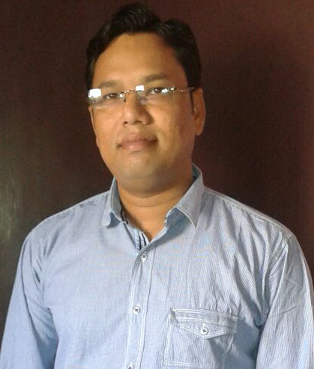

BISWAJIT SAMAL
WZ-80B 1, Naraina Village
New Delhi- 110028
Email id: biswajit8878@gmail.com
Mobile- 8882698625

Objective:
A challenging growth oriented carrier in the field of accounting in a progressive organization, where I can develop my skills and contribute the same towards organizations success.

EXPERIENCE SUMMARY: Total 13 Years+ Experience in Accounts Management
Work Experience:
Organization : Trubond Industries Private Limited
Duration : December 2017 to August 2019
Designation : Asst. Manager Accounts & Finance
Responsibilities
- Complete book keeping & accounting entries.
- Compliances of GST, TDS, EPF & ESIC
- Salary Processing & online payment of PF & ESI challans
- Preparation of various types of Monthly & weekly Reports (Expense Comparision, Budgeting, Cash Flow, P&L, Debtor Outstanding etc)
- Preparation of monthly Profit & Loss Accounts
- Export Documentation
- Reconciliation of Bank and Debtor, Creditor a/cs
- Follow-up of receivables on regular basis
- Direct reporting to Director and worked as team leader of juniors

Past Working Experience:
Organization : Krishna Builder
Duration : March 2017 to December 2017
Designation : Asst. Manager Accounts
Responsibilities
- Complete book keeping & day to day proceedings for different sites
- Compliances of TDS, GST, D Vat, O Vat, EPF & ESIC
- GST migration & other procedures (GSTR 3B, GSTR 1) for multiple states
- Preparation of self invoices for purchases / services from unregistered dealers & site transfers
- Reconciliation of Bank and Debtor, Creditor a/cs

Past Working Experience:
Organization : Fashion TV Group
Duration : November 2014 to February 2017
Designation : Asst. Manager Accounts
Responsibilities
- Complete book keeping & accounting entries.
- Compliances of TDS, Service Tax, Sale Tax, Excise, EPF & ESIC
- Salary Processing & submitting online PF & ESI challans
- Preparation of Balance Sheet, P&L Accounts & Trial Balance
- Fund Management & Payment Planning
- Co-ordination with statutory auditors
- Reconciliation of Bank and Debtor, Creditor a/cs
- Follow-up of receivables on regular basis
- Communication with supply partners
- Preparation of various types of Monthly & weekly Reports (MIS.Fund Management, Target of Divisions)
- Supervision of sales & purchases
- Direct reporting to Director and worked as team leader of juniors.
- Fund Management & Planning.
- Preparation of Financial & Profitability statement

Company Name : Giga Sales Enterprises Pvt. Ltd.
Duration : December 2011 to 2014.
Designation : Asst. Manager Accounts
Responsibilities
- Complete book Keeping & accounting entries
- Compliances of TDS, Service Tax, Sale Tax, EPF & ESIC
- Salary Processing & submitting online PF & ESI challans
- Preparation of Balance Sheet, P&L Accounts & Trial Balance
- Fund Management & Payment Planning
- Co-ordination with statutory auditors
- Reconciliation of Bank and Debtor, Creditor a/cs .
- Follow-up of receivables on regular basis
- Communication with supply partners
- Preparation of various types of Monthly & weekly Reports (MIS., Target of Divisions)
- Supervision of sales & purchases

Company Name : Intec Capital Limited.
Duration : September 2007 to December 2011.
Designation : Asst. Manager Accounts
Responsibilities
- Complete book Keeping & accounting entries
- CM & F & O File Processing in Shilpi software
- Payment Follow up from Clients & Branches
- MG-13 uploading,& Margin Funding, Short & Excess Margin of Clients
- Reconciliation of Bank (on daily basis).
- UCI upload (NSE & BSE) Supervision
- Distribution of dividend to clients

Firm Name : Rajiv Gupta & Co
Duration : May 2005 to August 2007
Designation : Audit Assistant

Educational Qualification:
- B.Com from Utkal University.
- MBA in Finance from Sikim Manipal University
Software Skills:
- Packages : M.S-Word, MS-Excel, Tally, Fact, Internet, Shilpi & Easysol.
Personal Details:

Fathers Name: Mr. Binaya Kumar Samal

Date Of Birth: 8th August 1978

Marital Status: Married

Current Salary: 40,000/- P M.

Expected Salary: Negotiable

Declaration:

I hereby declare that all the above informations are true and accurate of my knowledge.

Date:
Place: New Delhi (Biswajit Samal)

