
PRAMOD KUMAR KANAUJIA
A high-energy professional with a record of achievements, targeting for assignments in New Product Development/Production Planning & Control with an organization of high repute

Industry Preference: Automotive/Machinery
Location Preference: Delhi/NCR

+91 9911174506/9354450974 pramod.kanaujia@gmail.com

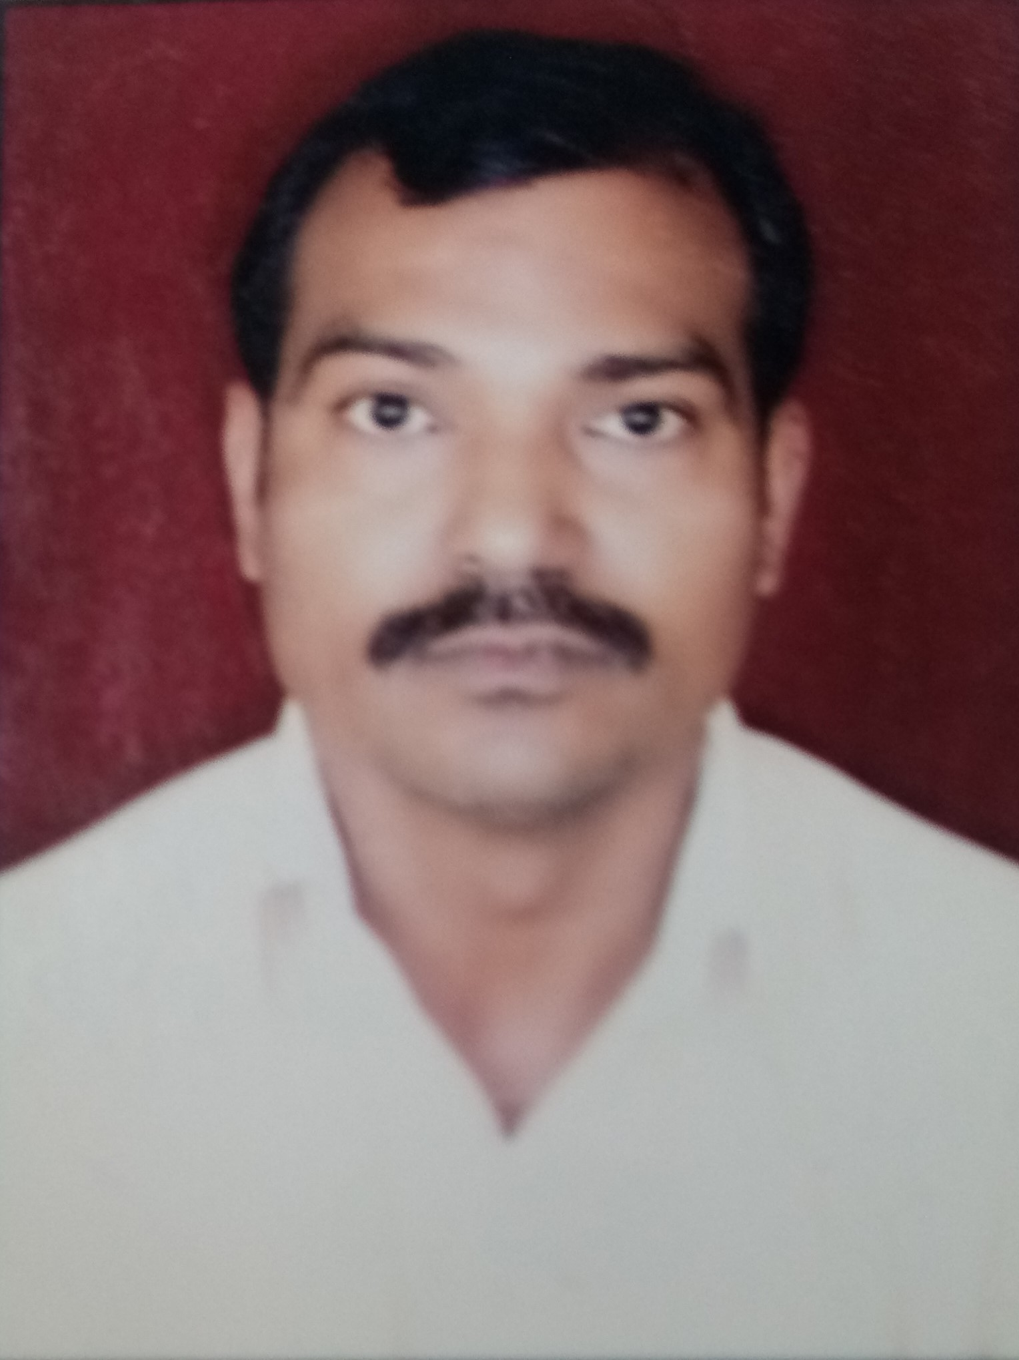
Core Competencies  New Product Development  Production Planning/Control  Quality Management  Process Enhancement/ CAPA Implementation  Cost Optimization/Budgeting  Project Management  Strategy Planning & Execution  Team Building & Leadership | Profile Summary  Offering nearly 29 years of experience  - Proven track record in implementing cost saving measures to achieve substantial reduction in terms of production, raw materials, manpower and machine utilization  - Resourceful in analyzing production systems/ processes, identifying loopholes and steering continuous improvement projects  - Experience in performing activities to enhance the process operations, optimize resource & capacity utilization, escalate productivity & operational efficiencies  - Expertise in machining process including Jig & Fixtures, Combination Tools, Poke-Yoke, selection of machines (SPM, GPM & CNC) for new projects and initiating VA/VE activities for cost reduction in the product & process  - Possess in-depth knowledge of General-purpose M/c, SPM, CNC Turning & Machining Center, Designing Jig & Fixtures & Machining Process Layout  - Designed comprehensive organizational-level strategy for managing project related operations involving design & development of processes, streamlining processes to facilitate smooth workflow & enhance productivity  - Versatile, high-energy professional, successful in achieving business growth objectives within turnaround & rapid changing environment with excellent communication, people management, analytical and problem-solving skills  - Working with SAP, PLM, Auto Cad Inventor and Ms Office.
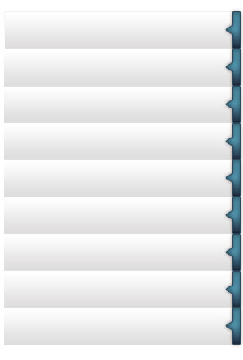
Career Timeline
M/s Ample Auto Tech (P) Ltd., IMT Maneser, Gurgaon
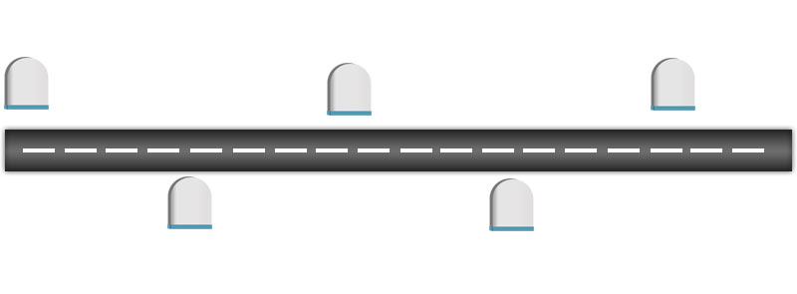
M/s Amtek India Ltd., Gurgaon
M/s Acme Auto (P) Ltd.,Faridabad
M/s Lohia Starlinger Ltd. Kanpur
M/s Roop Automotives Ltd., Sohna, Gurgaon
Soft Skills


Planner
Motivator
Collaborator
Communicator
Change Agent

Education  - 3Year Diploma in Mechanical Engineering (Specilisation in Production Technology) from U.P. Technical Board in 1990 | Previous Experience  - Attended the following trainings:  - Inspection & Quality Control from Institute of Tool Room Training, U.P. (ITTUP)  - Design of Gauges from Advance Training Institute, Kanpur (ATI)  - Design of Jig & Fixtures from Advance Training Institute, Kanpur (ATI)  - Advance Engineering Measurement from Central Tool-room, Ludhiana (CTI)  - Eliminating Waste for SME’S from CII, Gurgaon  - Low Cost Automation from ACMA, Gurgaon  - New Product Development in CNC Turning Centers by IMTMA, Gurgaon

Work Experience

M/s Roop Automotives Ltd., Sohna, Gurgaon Mar’08-Present
Deputy Manager (New Product Development) Mar’12-Prasent
Assistant Manager (Production) Mar’08-Mar’12

Key Result Areas:
- Managing products like steering column yokes, steering column sub-assemblies, commercial steering system, universal joints, differential cases and gear box housing, precision turned parts & machined parts, pto adopters and sleeves.
- Coordinating the entire product development including time plan, requirement analysis, finalizing specifications, designing, prototype development and testing activities
- Spearheading development of new products, its process and making in-house development plan, which include arrangement of all facilities and trainings required for production, samples and pilot lot making
- Conducting feasibility meeting with all CFT members and addressing customer specific requirements during meeting
- Developing new tooling and implementing fixtures of SMED (Single Minute Die Exchange) on machines
- Implementing continuous improvement projects to reduce set-up change over time, set-up time, cycle time and tooling cost
- Establishing targets for the team to match corporate goals, short-term and long-term budgets and developing business plans for the achievement of these goals
- Making plans for day-to-day activities, production schedules, implementing quality tools and allocating work for achieving monthly production targets
- Monitoring/ tracking projects with respect to budgeted cost, demand forecasts, time overruns to ensure timely execution of projects
- Ensuring quality product delivery; managing operations related to production planning including coordinating in marketing, manpower management, supplies and uptime of equipment
- Formulating SOP (Standard Operating Procedures), implementing effective techniques to bring efficiency, improve quality standards & achieve maximum cost savings
- Administering down line development with close interaction, situational training and idea generation for implementation of new improvements in operation, SAP, documentation, machine operation and energy save options
- Ascertaining adherence to regulatory needs, compliances and up keeping of facility for any audits at any time

Previous Experience

M/s Ample Auto Tech (P) Ltd., IMT Maneser, Gurgaon Feb’07-Mar’08
Assistant Manager (Engineering Department)

- Gained exposure in working with products like Tie rod end, Ball joints, Drag link assembly, Rack end, Steering linkage assy. And Repair kit for heavy & light commercial vehicles for export market
M/s Amtek India Ltd. Gurgaon Mar’02-Feb’07
Engineer (Engineering Department)

- Gained exposure in manufacturing of various types automotive components like Power Transmission Forks, Piston, Connecting Rod, Crank Shaft, Flywheel, Steering Knuckle, Under Bracket Assy
M/s Acme Auto (P) Ltd.,Faridabad June’99-Mar’02
Senior Engineer (Design & Development Department)
- Gained exposure in managing products like Transmission Forks, Speedometer Gears, Armature Shaft of self-starter, Kick ratchet for M/s Maruti Udyog Ltd., M/s Hero Honda Ltd., M/s Yamaha Motors India Pvt. Ltd., M/s Monto Motors Ltd., M/s Auto Ignition Ltd. and many other companies
M/s Lohia Starlinger Ltd. Kanpur Aug’90-May’99
DET, Assistant Engineer


Personal Details
Date of Birth: 20th February 1970
Languages Known: English and Hindi
Present Address: H. No. 1794, Maruti Kunj, Sector – 67 Gurgaon-122102, Haryana
Permanent Address: L.I.G. 55, Indira Nagar, Kanpur-208026, Uttar Pradesh

