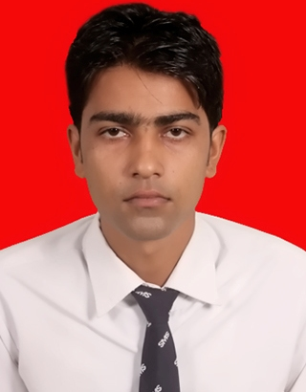
Resume

Ashish Singh
E-mail : ashish80979@gmail.com
Contact No.: 6388427789
Address for Correspondence :
House No. C-26 Vrindavan Colony P.2
Chitaipur Amara ByPass Varanasi
Pin No. 221003

CARREER OBJECTIVE

Looking for responsible and challenging carrier, where my skill can be effectively utilized & contributed for organization success.

Organization Experience

1. I have worked with August/10/2016 to 13/ September /2017 HDB Finance Services in Gurgaon Haryana(Operating under HDFC Bank) as a Relationship Executive.

Work Profile –
I have sell Credit Card, Merchants Acquiring, General Insurance and generate leads personal loan, bike loan, car loan.

2. I am working with 11/Dec/2017 to 30/01/2019 now Dataman Computer Services PVT. Ltd in Varanasi as Relationship Executive.
Work Profile – I have Sell Hotel and Hospital Management Software and Work Support and Services those Software.

3. I am working with 20/Feb/2019 to Till Now Workforce Infotech Pvt. LTD. In Varanasi as Area Manager.
Work Profile – I have Sell Website , Digital Marketing , Product Listing , School ERP , Logo and Inventory Software and I have Handle a team for Sales and Marketing.

Area of strenght

Motivating People
Leadership
Responsible
Listening

Computer Skill

C , C++ , Dot Net , HTML,PHP, M.S. Office , Internet surfing.

PERSONAL SKILL

Alert: Watchful awake, ready to act.
Calm: Stillness, serenity, peaceful.
Capable: Having the skill/ability or fitness for.

ACADEMIC QUALIFICATION

Qualification | Institute / Board / University | Year of Passing | Percentage / Grade
Master of Computer Applications | UTTAR PRADESH TECHNICAL UNIVERSITY | 2017 | 60.00
Bachelor of Computer Applications | CCS UNIVERSITY MERRUT (UP) | 2013 | 67.16
Intermediate | UP BOARD | 2010 | 53.2
High School | UP BOARD | 2007 | 51.67

Extracurricular Activities

- Served as coordinator in college in an effective manner.
- Actively participated in devotional events.
- Showed distinctive ability by taking the business responsibility.

HOBBIES

Watching news
Animal care
Volunteer Work

PERSONAL DETAIL

Name : Ashish Singh
Father’s Name : MR. Ratna Prakash Singh
Date of Birth : 15/07/1993
Sex : Male
Marital status : Married
Permanent Address : Vill+Post- Ramgarh Kalan Sikhar
Chunar Dist. Mirzapur(U.P.)
Pin No.- 231306

Declaration

I hereby declare that all the information furnished above is correct to the best of my knowledge & belief.

Date : 20/ 01/ 2020 

