**RESU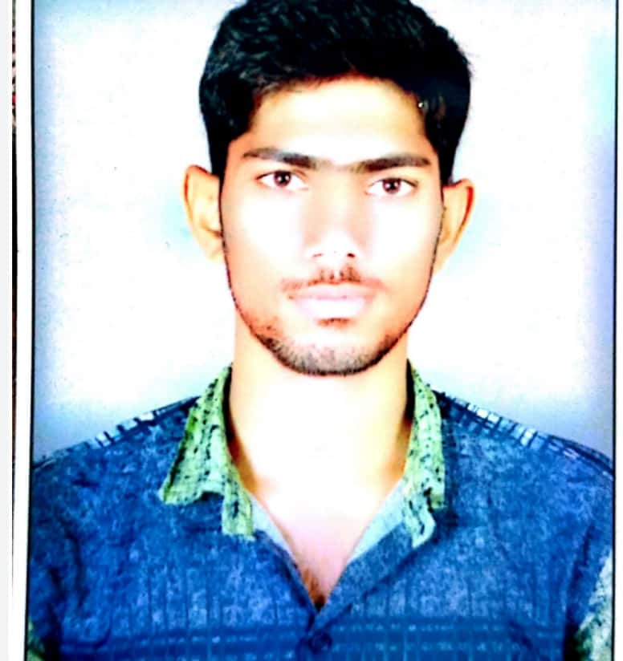ME**

**PRAVEEN BHARADWAJ AMETA**

**Address:**

Vill – Jodhras, Vaya- Raila

Dist- Bhilwara, State – Rajasthan

E-mail: [-praveenbharadwajameta@gmail.com](mailto:-praveenbharadwajameta@gmail.com)

Mobile No.- 8740841219

**CAREER OBJECTIVE**

I want to work with this organization where I can improve my skills as well as benefited the

organization

**ACADEMIC QUALIFICATION**

|  |  |  |  |
| --- | --- | --- | --- |
| **Examination** | **Board/ University** | **Year** | **Agg/Percentage** |
| 10th | **Board of Sec. Education, Rajasthan** | 2011 | 59.50% |
| 12th | **Board of Sec. Education, Rajasthan** | 2014 | 52.80 % |
| Diploma (Mechanical) | **Bord of Technical Education Jodhpur** | 2016 | 59.42% |
| B.Tech.  (Mech.) | **Rajasthan Technical University** | Result Awaiting | 60.40 % |

**PROJECTS**

* Design and constructed speed breaker energy conversion system.
* Constructed Paddle Operated hacksaw.
* Constructed hand lever Tricycle.

**INDUSTRIAL TRAINING EXPERIENCE**

* 24 Days Internship in ROLEX RINGS PVT LTD Rajkot Gujarat.
* Internship in KANCHAN INDIA LTD Bhilwara Rajasthan.
* 16 months experience in Production Department in PSA AVTEC POWERTRAIN PVT LTD hosur Tamilnadu.

**COMPUTER SKILLS**

Basic Knowledge of Computer, MS word, MS power point, basics of Ansys, Internet

**Strength**

Ability to work under pressure and achieve target maintain deadline Goal oriented, self

and excellent leadership leader.

**Personal Details**

**Father’s Name :**  Ashok Kumar Bharadwaj

**Date of Birth :** 02-08-1997

**Nationality :** Indian

**Gender :**  Male

**Marital Status :** Unmarried

**Language Known :**  Hindi, English & Regional **Date:-26/12/20**