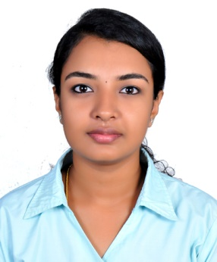

**GREESHMA ANIL S**

+91-9495366967

greeshmaanils0803@gmail.com

**Career Objective**

To work in tandem with a team in a challenging and competitive environment where I could improve my knowledge, capabilities and put them to use for the development of the organization.

**Academic Achievements**

|  |  |  |  |  |
| --- | --- | --- | --- | --- |
| **COURSE** | **YEAR** | **COLLEGE** | **UNIVERSITY** | **SCORE** |
| MBA | 2018-2020 (Pursuing) | CET School of Management Thiruvananthapuram | APJ Abdul Kalam Technological University | 7.67GPA(T1)  7.67GPA(T2)  7.86GPA(T3) |
| B.Tech (Computer Science& Engineering) | 2013-2017 | St. Thomas Institute for Science and Technology, Thiruvananthapuram | Kerala University | 6.42 CGPA |
| XIIth Standard (Science) | 2011-2013 | Navajeevan Bethany Vidhyalaya Nalanchira, Thiruvananthapuram | CBSE | 63% |
| Xth Standard | 2010 | Mary Nilayam EMHSS, Thiruvananthapuram | CBSE | 9.0 GPA |

**Internship and Training**

**Job Title** : HR Intern

**Duration** : February 2018 – April2018

**Company** : Sherji Technologies

**Brief Description** : Gained an extensive knowledge in handling the day to day operations in a firm, maintaining client relationship, handling recruitment process which includes sourcing, shortlisting candidates according to the requirements and scheduling interviews with the technical person, documentation and also managing the employees with their requirements.

**Job Title** : Project Intern

**Duration** : June 25th 2019 – August 8th 2019 (45 Days)

**Company** : Food Safety Department, Trivandrum

**Brief Description** : Got a chance to work in a Govt. department and was able to contribute my knowledge for the re-development of the department.

**Technical Skills**

Hiring tools : Proficient in using Naukri and Monster.

Operating Systems : Proficient in Ubuntu (Linux), Microsoft Windows 8&10.

Programming Languages: Java, C, C++, Embedded C.

Productivity Tools : Proficient in Microsoft Office, Microsoft Excel.

**Achievements**

* Participated in a workshop conducted by IIM-B about “Startup Fundraising”.
* Participated in Best Management Team and Strategic Management in National level Management Fests.
* Volunteered for Humanizing Work and Work Environment (HWWE) Dec 2018 and for EDVENTURE’19 Innovation and Entrepreneurship summit.
* Volunteered for college fests “Drishti” and “Yamistha”.

**Hobbies/Interests**

* Drawing, dress designing and listening to music.

**Personal Details**

|  |  |
| --- | --- |
| Name : | Greeshma Anil S |
| Date of Birth : | 8th March 1995 |
| Nationality : | Indian |
| Father’s Name : | V Anil Kumar |
| Mother’s Name : | Sathy Anil |
| Permanent Address : | Thiruvonam Manvila, Kulathoor PO TVM |
| Language Known : | English, Malayalam |
| Marital Status : | Single |
|  |  |

**Declaration**

I hereby do declare that the details given above are true to the best of my knowledge.

Place: Trivandrum

Date: