SUMIT SHARMA

Experience

4 Years
Computer Hardware & Software Faculty in ITIL, Jodhpur.
2 Years
Computer Lecturer & Examination Controller in MCRPV Franchise Center Vinayak Seva Sansthan Dungarpur.

2 Year

Sr. Computer Opt. Faculty in Bal Vishwa Bharti Sr. Sec. School Jaipur.

3 Years
Academic Coordinator in NIFA
2.5 Years
Corporate Advance Excel Trainer with wisdom Hall.
7 Years
State Head Govt. Project in NIFA
Nov. 2019 to Till Continue
Data Analysis and Tender Work in M/s Shivakriti International Ltd., Jaipur (Raj.)

Education

12th Commerce

BCA

MSC (CS)

Professional Qualification

Hardware, C, C++, HTML, VB etc.

Strength
Sincerity, Down-To-Earth Attitude, Team Work are integral part of my character. Ready to undergo any kind of training and transformation to enhance professional skills. Ability to work in team.

work efficiency
- Govt. Projects Handled Like RSLDC-ELSTP, DDU-GKY, RSTP
- Tendering Work in Railway
- All MIS Work

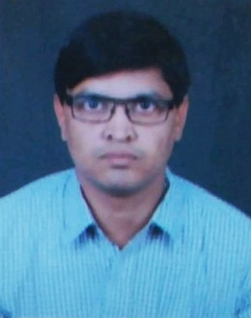

 | Plot No. 95, Shanti Nagar Opp. NBC, Khatipura Road  Jaipur-302006 (Rajasthan)
 | 9461662361
 | System.sumit@gmail.com
 | Corporateexcel.com

Objective
To achieve good position in corporate sector, and to make use of my skills effectively for the growth of my organization.

