SUBHASIS DAS
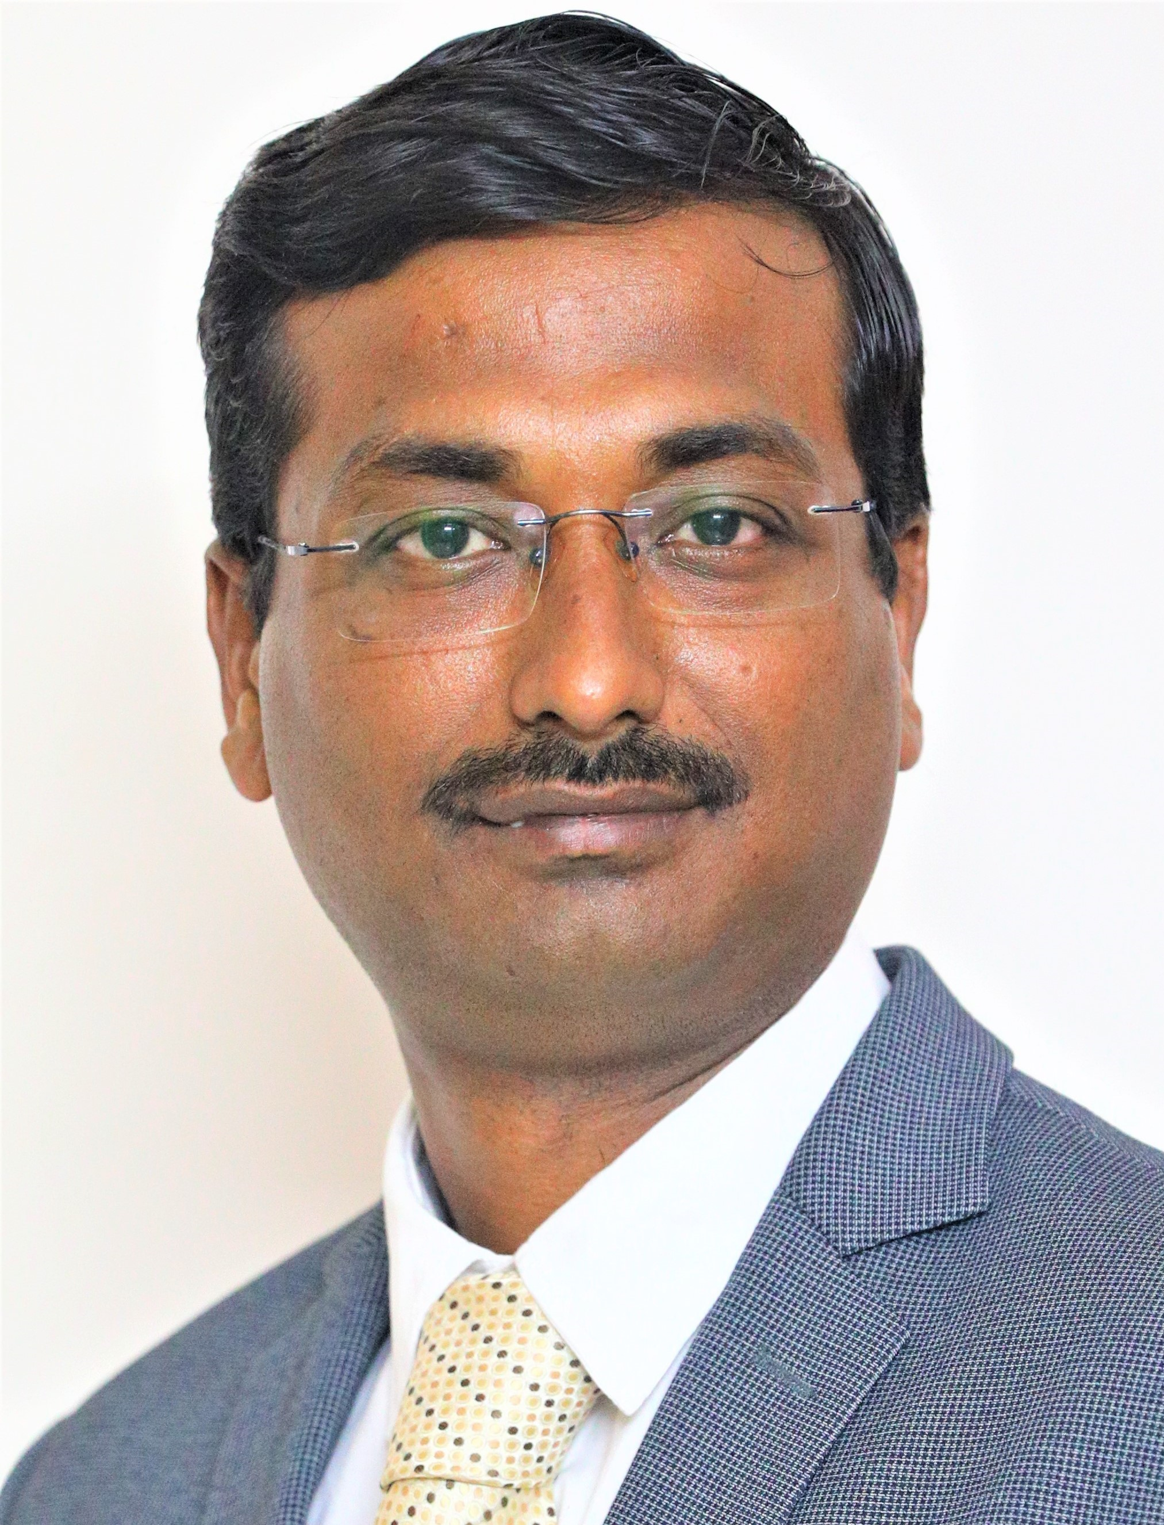

Business Executive, Entrepreneurial Strategist & Financial Analyst
Career Aspiration – Build, drive & lead an energetic team to make sustainable & tangible financial growth of the organisation with high level of collaboration.

Phone: +91 9840385549
E-mail: sdaspe@gmail.com / subhasis.fx20038@greatlakes.edu.in
Address: F-601, Mantri Synergy, 1/124B, OMR, Chennai - 603103
LinkedIn: https://www.linkedin.com/in/subhasis-das-9530b445/

CAREER OVERVIEW

Visionary, agile & results-oriented leader with a strong track record of performance. More than Twenty (20) years of accomplished experience in P&L Management, Strategy, Business Development with the demonstration of solid analytical and team management skills. Excellence in generating new business through collaboration & strategic negotiation while cultivating relationships with key decision-makers in various industries.

EXPERTISE & SKILLS
- Communication, Strategy, Pro-active decision making and networking.
- Persuasive skills and ability to delivering presentation.
- Listening, writing credible, Sharing thought and ideas effectively.
- High level of IQ/EQ/LQ with Resilience & emotional intelligence to inspire & transform others.
- Financial analyst, Cash flow management and activity-based cost & profitability management
- Excellent Commercial acumen and compliance to policy, regulation & law.
- Strategic Human Resource management, conflict management and able to break silos.
- Technical knowledge in Mining & Mineral Processing including Beneficiation Process, Crushing, Grinding, Separation, Sedimentation, Filtration & Pelletisation.
- Significant experience in Multidisciplinary EPC Project (which includes Mechanical, Electrical, Structural, Civil, Erection & Commissioning) including Project, Operation & claim management.
KEY PERFORMANCE AREAS
- Handling Profit & loss and maintaining positive networking capital and smart cash-flow
- Strategic Business Development, Key account management & Relationship building.
- Strategic business plan for long term and short-term business, formation of JV/Consortium, Analyze customer behaviour, Risk assessment and formulation of sales strategy to ensure attainment of company goals and profitability.
- Keeping track & knowledge of competitor’s strategy, product development and Pricing policy.
- Facilitation and critical problem solving and building synergy
- Negotiation, contract finalisation and contract closure.

EMPLOYMENT DETAILS

Deputy General Manager – Mining Since 18th June’2012 to Present
FLSmidth Private Limited, Chennai - A Danish MNC & technology provider for Mining, Cement, Mineral Processing, Material Handling.

Key Responsibility – Leadership, Strategy, Collaboration, Business development & sales of Capital Projects & Equipment (Mining & Mineral processing). Accountable for revenue (P&L) of INR 3500 million per year. Brand management & promotion for future growth to generate tangible benefit in B2B sales.

Chief Manager (Sales) 7th Sept’ 2009-15th June’2012
allmineral Asia Pvt. Ltd. /Hazemag India Pvt. Ltd./ Cemtec India Pvt. Ltd., Kolkata – A European MNC & equipment supplier for Mineral Processing Industry.

Key responsibility – Team leader, strategy, business development & sales of Mining, Mineral Processing & Palletisation (CPT) projects & equipment.
Accountable for revenue of INR 1500 million per year.

Head – Strategic Business Unit 6th August’ 2007-4th September’2009
Tega Industries Limited, Kolkata - An Indian MNC & Manufacturer of Equipment & Consumables for mining & Mineral Processing Industry.

Key responsibility – P&L management, strategic cost & profitability management, business development & sales. SBU head of mill liner, screen media, mineral processing equipment (Hydrocyclone & mineral processing simulation software - JK Simmet/Simfloat) business.

Manager (Sales) 9th August’ 2004-3rd Aug’2007

Mitsui & Co. Ltd. – A Japanese MNC & one of the largest conglomerates covering business area of Mining, energy, machinery, chemicals, food, textile, logistics.

Key responsibility – Country representative, business analytics, brand & portfolio management, decision making, operation & business development. Responsible for business of OTR tyre, HEMM and conveyor belt for the Mining Industry.

Business Development Manager 5th May’2003-6th August’2004

Asiakom Sdn Bhd, Kuala Lumpur – A leading EPC contractor for Railways, Infrastructure & Ports.

Key responsibility – Planning, operation & business development of Railway construction and Infrastructure development Projects in South East Asia. Handled critical contracts closing and responsible for International business strategy & strategy simulation.

Marketing Manager 10th August’1999-13th April’2003

Rahee Industries Limited, Kolkata – A leading Indian Manufacturer of Permanent way (Railway) Products.

Key responsibility – Design, engineering and proposal preparation for multi-disciplinary railway project and products (Points & Crossing, Switch Expansion Joints, Glued Insulated Joints, Steel Sleeper, Welded Crossings, girder bridge etc.). Relationship management with Indian & overseas railways, consultant and partners. Successfully executed multiple JV's& consortium agreement with global partners.

EDUCATION

- MBA (PGPM-FLEX) in Finance from Great Lakes Institute of Management
- AMIE (Mechanical Engineering) from Institution of Engineers (India)
- Diploma (Production Engineering) from Nazrul Centenary Polytechnic

SPECIALIZATION & TRAINING

- Business Leaders & Leading Others by LPI Institute, Denmark,
- On Conceptual & Strategic Selling by Miller & Heiman, UK
- On Sales Mastery, Strategic Sales Negotiation & Value Selling by Mercuri International
- On JK Simmet from JK Tech, Australia
- On Mineral beneficiation from SDS Autonomous College, Shreeramnagar
- On Safety in Railway project from KTMB, Malaysia

WEIGHTED LEADERSHIP & MANAGEMENT EXPERIANCE

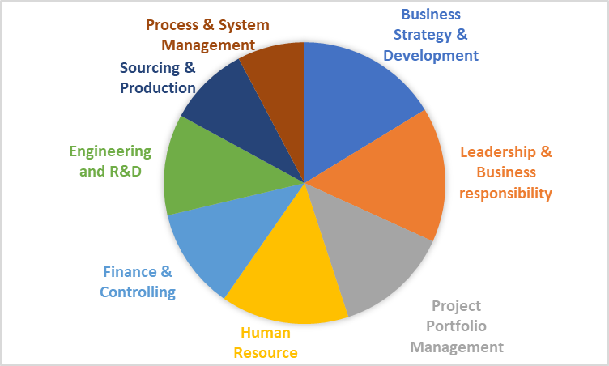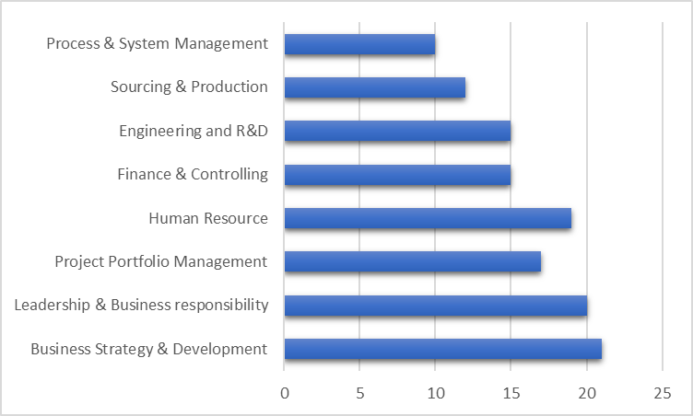

PERSONAL DETAILS
Date of Birth: 7th January 1978

Permanent Address: PRO-E-105, Aponaloy, 322 New Jessore Road, Kolkata – 700132
Family: Married & Two Children
Interest: Networking, Fitness, Art, Cricket, Badminton

Chennai, Tamil Nadu SUBHASIS DAS, 31/07/2026

