Kumar Abhishek
Electrical & electronics engineer

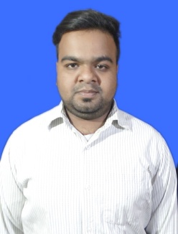 | Name : Kumar Abhishek  Address : Kailash Nagar, PO+PS – Chas, Bokaro, Jharkhand – 827013  Mobile no. : 9304378074  Date of Birth : 12/05/1998  Religion : Hindu  Nationality : Indian  Martial status : Unmarried  Email : 76796abhishek@gmail.com

Objective
Seeking challenging in your reputable company to work in electrical & electronic field.

KEY STRENGTH
- Responsible, hard working attitude with strong determination and sincerity.
- Can adjust easily to new environment with keenness to learn.

INTEREST AND HOBBIES
Writing Poetry, Playing Cricket

Educational QUALIFICATION
- Bachelor In Engineering (B.E) in Electrical And Electronics Engineering
- Specialization : Electrical And Electronics
- Institute : Technocrats Institute Of Technology (Bhopal)
- Awarded Date : June 2020
- Diploma In Electrical Engineering
- Specialization : Electrical Engineering
- Institute : Bengal College Of Polytechnic (Durgapur, West Bengal)
- Awarded Date : June 2017
- Secondary School Qualificaton
- Specialization : Matric
- Institute : Pentecostal Assembly School
- Awarded Date : May 2014

project report
Done a Project Training From Steel Authority Of India Limited (SAIL) Bokaro Steel City Jharkhand On The Topic Focusing On Telpher And Winch Panel.

personal qualities

- Result Oriented Person
- Quick Observer of the work given and a keen learner
- Responsible and Sincere towards the task
- Create a good working environment in the industry

extra curricular activities
- Participated in “ ROBONIXX” a Robot creating and displaying show arranged
In college
- Won many cricket tournaments at inter college level

