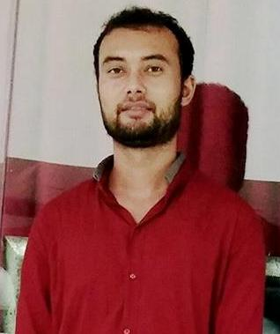**MANOJ SINGH AIRY**

**Mobile: +91-7396282179**

**Email: airy.manoj1@gmail.com**

**CAREER PROFILE:**

* Having about 5 years of industrial experience and keeping in the view of my academic knowledge, personal strengths. I wish to associate myself with and well reputed organization that provides me an enthusiastic environment to work creatively and collectively for the growth of organization and always keeping the organization goals as a top priority.

**ACADEMIC QUALIFICATION:**

|  |  |  |  |
| --- | --- | --- | --- |
| **Course (Stream)/Examination** | **Institution/University** | **Month/ Year of Passing** | **Percentage** |
| DIPLOMA IN (MECHANICAL) | FROM UK BOARD OF TECHNICAL EDUCATION ROORKEE | 2013 | 64 |
| 10th+2 PASS | FROM UA BOARD | 2010 | 50 |
| 10th PASS | FROM UA BOARD | 2008 | 69 |

**KEY SKILLS:**

* Expertise in maintaining all measure norms effectively,
* Use effective strategies to minimize risks.
* Well verse with safety procedure.

**PERSONALITY TRAITS:**

* Goal oriented and self-motivated.
* Excellent interpersonal skills.
* Efficiency of managing multiple tasks.
* Hard working and flexible to work in shifts.

**PROFESSIONAL INDUSTRIAL EXPOSURE:**

.

* Company: POWER MECH PROJECTS Ltd.

Projects : Rayalaseema Thermal Power Plant.

Location : Muddanur, Andrapradesh, India.

Duration : March 2014 to April 2018

Client : BHEL.

Costumer : AP GENCO (1X600 MW).

Position : Engineer (Structure erection )

* Company: POWER INFRA MECH PROJECTS Ltd.

Projects : **STPP Phase-I Project,**

Location : Ramagundam, Telangana, India.

Duration : Sep 2018 to Still Date.

Client : BHEL.

Costumer : NTPC(2X800 MW).

Position : Sr.Engineer (Structure erection ).

**ROLES RESPONSIBILITIES:**

* Role as an Executive engineer in Boiler Structure erection and responsible for day to day erection activities as per the work schedule.
* Responsible for optimum utilization of man hours and quality of the job done.
* Keeping safety of the workmen as a prime activity.
* Responsible for sub contractors’ coordination in day to day erection activities at site and maintaining cordial relation with principle client.

.

**PERSONAL INFORMATION:**

Fathers Name : RAM SINGH AIRY.

Nationality : Indian

Religion : Hindu

Date Of Birth : 1st july,1993.

Marital Status : Married

Address : ( **DHARCHULA PITHORAGARH )**

**( UTTARAKHAND )**

**HOBBIES:**

* Watching movies.
* Playing cricket.

**DECLARATION**

I do hereby declare that all the information given above is true to the best of my knowledge and belief.

**Place:**

**Date: SIGNATURE**