

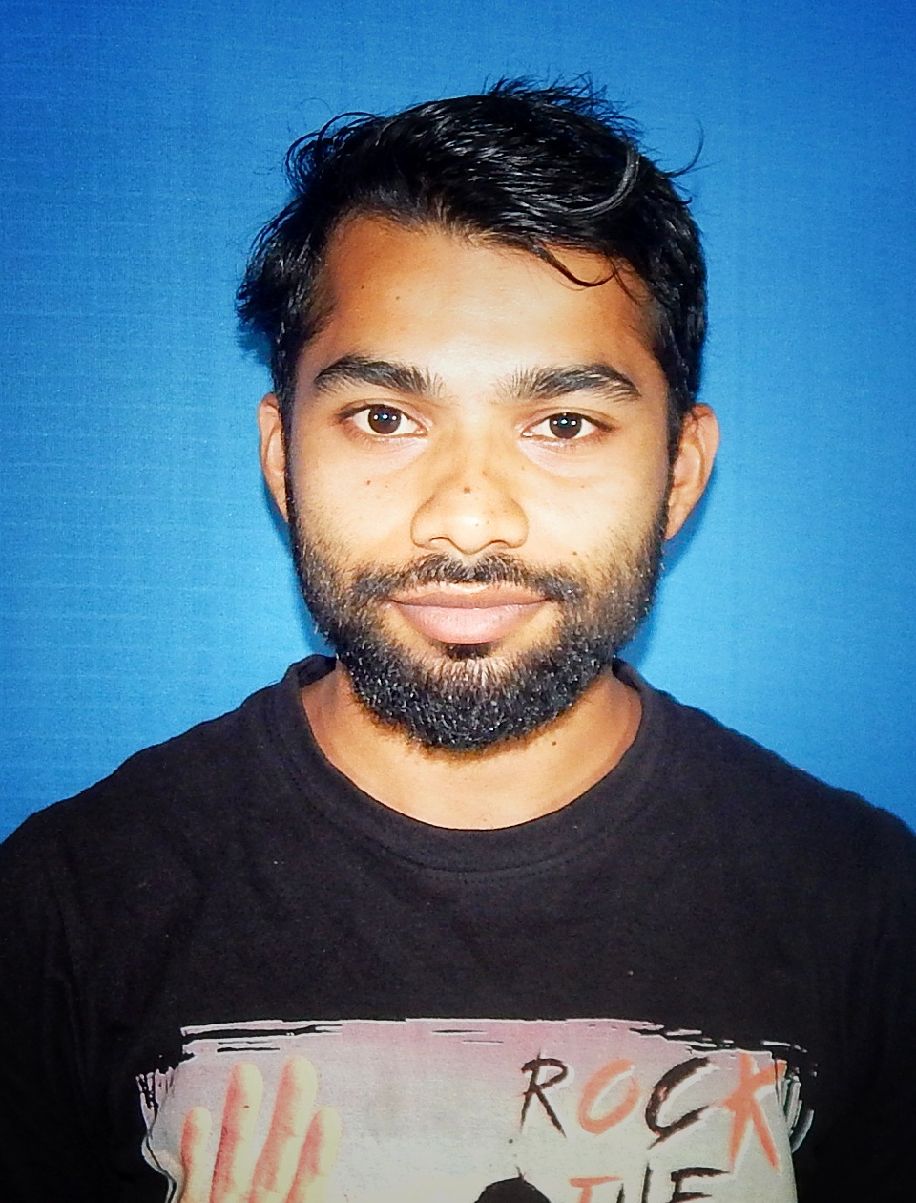

**SOMENATH MAHATA**

**B.Tech. – ECE**

**Ph:** +917865060343

**Email:** somenathmahata9@gmail.com

Chandra, Paschim Midnapur, India - 721102

**CAREER OBJECTIVES:**

To be able to work for an encouraging and stable company that will assist me in developing, improving, and obtaining the necessary skills in order to become the best engineer possible. I am looking forward to challenging my potential and be worthy of Management trust and confidence.

**ACADMIC QUALIFICATION**

**Aryan Institute of Engineering and Technology**  2017 - 2021

B.Tech. - ECE | CGPA: 00/00

**Chandra High School, West Bengal, Paschim Midnapur**  2017

12th | WBCHSE | Percentage: 64.00/100.00

**Chandra High School, West Bengal, Paschim Midnapur** 2015

10th | WBBSE | Percentage: 73.42/100.00

**SKILLS:**

* Good communication Skills
* Quick Learner

**COMPUTER SKILLS**

* Course on Computer basic Concept( 3 Months)

**EXTRA CURRICULAR ACTIVITIES**

* Volunteer in different cultural programme.
* Participation in sport.

**PERSONAL INTERESTS/ HOBBIES**

* Playing Outdoor Games (Football, Cricket)
* Writing, Drawing

**PERSONAL PROFILE**

**Father Name:** Gokul Mahata **Date of Birth:** 17/09/1997

**Gender:** Male **Known languages:** English, Bengali, Hindi

**Marital Status:** Unmarried

**Current Address:** Chandra, Paschim Midnapur, **Permanent Address:** Chandra, Paschim Midnapur

West Benga, 721102 West Bengal , 721102

**Email:** [somenathmahata9@gmail.com](mailto:somenathmahata9@gmail.com) **Phone Number:** +917865060343, +917602802685