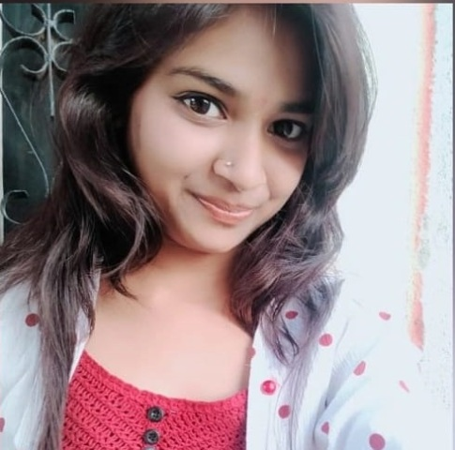
SHILPI VARMA
Master Of Computer Application
Address: - Village-tikhad teh- itarsi dis- hosangabad (M.P.) 461115
Mobile No. : - 9109379567
Email Id: - vshilpi417@gmail.com

OBJECTIVE

I strongly believe to contribute positively towards the growth of organisation its profit objective & establish a mutually beneficial relationship in long term and to establish a good career.

EDUCATIONAL QUALIFICATION

Description | Board /University | Year of Passing | CGPA/ Percentage
MCA | Rajiv Gandhi Proudyogiki Vishwavidyalaya, Bhopal  Madhya Pradesh | 2021 | 76.00%
B.Sc | Barkatullah University,Bhopal | 2019 | 61.10%
HSC | Board of Secondary Education, Madhya Pradesh | 2016 | 71.80 %
SSC | Board of Secondary Education, Madhya Pradesh | 2014 | 76.83 %

PROJECTS

- Online Store app Developed by Python

TECHNICAL SKILLS

- C Programming Language
- C++ Programming Language
- Python Language
- Tally

STRENGTH

- Self Confident and Responsible.
- Work With Innovative Mind Setup.
- Willing To Adopt New Challenges and Technologies.
- Well Managing Power.
- Sincere and Honest.

KEY SKILLS

- Good motivational and communication skills.
- Ambitious, Enthusiastic and dedicated to work.
- Leadership Qualities.

HOBBIES

Coding , cooking
PERSONAL DETAILS

Name : Shilpi Verma
Date of Birth : 23/01/1998
Father’s Name : Mr. Chandrika
Mother’s Name : Smt. Uma
Sex : Female
Maritial Status : Unmarried
Nationality : Indian
Languages Known : English, Hindi

DECLARATION

I do hereby certify that the information provided above is true, correct and complete to the best of my knowledge and belief.

Place:-

Date:-

(Shilpi varma)

