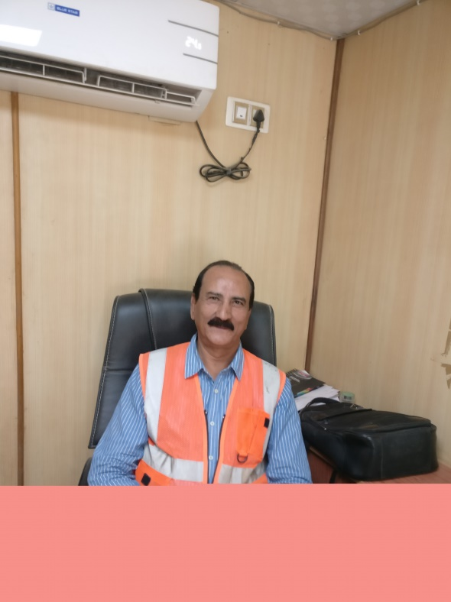

SALIL KUMAR GANGULY

SENIOR MANAGEMENT PROFESSIONAL
Enterprising leader & planner with a strong record of contributions in streamlining operations, invigorating businesses, heightening productivity, systems & procedures targeting assignments in Sales & Marketing, Process Design & Plant Commissioning and People Management
salil.nalco@gmail.com
+91-9831054417

Profile Summary
Extensive experience in managing multi-diverse functions in multi-site global environment with career success in developing & executing business strategies to accomplish top & bottom-line profitability.

Decisive, strategic and performance-driven professional with experience of augmenting business, penetrating new markets for business excellence, managing sales & marketing planning through market sizing, target setting & distribution across geographies by utilizing strong business & commercial acumen. A principle executive ‘point of contact’ for the company for ensuring that appropriate business strategies are in place and are acted upon as per the priorities.

Added value to the efforts of the organization and drove organizational objectives by successfully managing contracts, clients, business & proposal development, sales & marketing, techno-commercial operations, project financials. Impressive success in achieving profit, and business growth objectives within start-up, turnaround & rapid-change environments.

Rich experience in the field of mineral processing plant operations and process & plant design. Expertise in providing leadership & consultancy on operations & maintenance of mineral beneficiation plant including Coal, Iron, Sulphide, Rock Phosphate, Fluorspar, Rare Earth as well as design & building any mineral processing plant, starting with ore mineralogy to process plant design.

Impeccable record of leading high performance teams, implementing continuous improvement programs, partnering with major industry players & stakeholders. Excellence in managing annual target in the range of INR 450 to 500 Crores- 65-70 M US$.

Key Impact Areas
SBU Management | Market Share/ CAGR/ P&L Growth | Sales & Business Development
Project Management/ Leadership | Client/ Stakeholder Engagement | Operational Excellence/ Improvement
Process Plant Design/ Operations/ Commissioning Consultancy | Strategic Alliances & Partnerships | Team Building & Leadership

Career Timeline

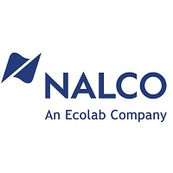
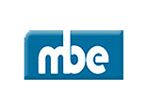
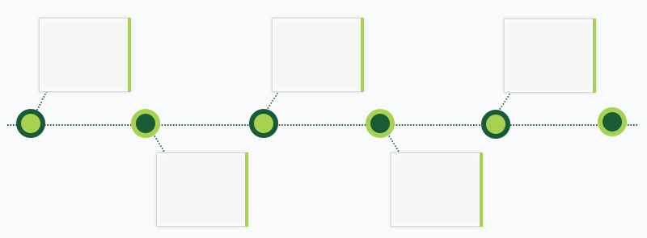
1980-1992
Sr. Engineer (Process)
1992 to 1996
Sr. Design Manager (Process)
1996-2013
Sales Manager, India & SEA
Since 2013
Vice President Mineral Beneficiation
Work Experience

Since May’13 with McNally Bharat Engineering Co. Ltd., Kolkata, India as Vice President, Mineral Beneficiation

Key Result Areas:
- Working as Head of Engineering (Process) and planning, organizing, directing, & controlling operations through business excellence philosophy
- Rendering support to SBU- Mineral Processing / Oil & Gas/ Fertilizer & Chemicals as Head of Process Engineering
- Leading a team of 50 qualified designers from all engineering disciplines and drafting hands
- Managing an annual target in the range of 450 to 500 crores (INR): 65-70 M US$
- Heading business operations with key focus on bottom line profitability by ensuring optimal utilization of resources
- Liaising with mgmt. for evolving strategic vision, driving change, improvements and infusing new ideas for next level performance
- Establishing operational strategic target plan & vision for driving business growth to achieve targeted departmental goals & KPIs; maintaining effective cost controls, capital and assets
- Mentoring, motivating & monitoring the performance of team members to ensure efficiency in process operations; organizing regular periodic meetings & trainings for staff for discussing issues and devising solutions for same
- Expanding business in the assigned territories and consistently improving profitability of the company; identifying new streams for long-term revenue growth
- Collaborating with mgmt. to prepare annual business plans, budgets and cash flow and reviewing the same periodically
- Ensuring physical and commercial closure of projects with support for P&L responsibility

Major Projects:
- Led the successful execution of total engineering deliverables & plant commissioning:
- 250 TPH Pet-coke Handling Package for Manali Refinery, Chennai Petroleum including Pipe Conveyors, Circular Stacker & Re-claimer, Wagon & Truck Loading – 230 Cr
- 2.7 MMTPA Pb-Zn Beneficiation Plant (Retrofitting) for Hindustan Zinc at Zawar Mines, Udaipur – 160 Cr (27 M US $)
- 2 MTPA Pb-Zn Beneficiation Plant for Hindustan Zinc at Zawar Mines, Udaipur- 300 Cr (43 M US $)
- SA & Africa: Worked on NOKENG Fluorspar Beneficiation Project for Sepfluor, SA- Order with value – 85 M US$

Previous Experience

1996-2013 with Nalco Chemicals, An ECOLAB Company, Kolkata, India as Sales Manager, India & SEA, Global Mining Division (Mining & Mineral Processing)

Highlights:
- Steered efforts in developing new business accounts and maintaining existing customer relationships
- Drove the sale of programs to the related market place in Coal, Alumina, Non-ferrous, Iron, Phosphate Fertilizers and Earth Minerals in India & SEA
- Headed a team of 3 Managers and 35 Sales Personnel to maximize market share & profitability through aggressive & speedy implementation of SMP and value-driven strong customer relationship management
- Mentored sales force including different SBU Sales Representatives in Thailand, Malaysia, Laos, Vietnam, Philippines & Indonesia
- Contributed in ensuring zero accident in the entire tenure as a Manager
- Augmented SBU sales revenue five-fold in the last 9 years with profit growth with a CAGR over 15% in the same tenure
- Streamlined & turned around struggling fertilizer business through in-house product & application development
- Pioneered the set-up of SBU Equipment Solution Team and successfully executed more than US $4 Million engineering projects at various Coal and Alumina Customer Sites
- Coordinated for controlling and reducing DSO (Days Sales Outstanding)
- Bagged prestigious award ‘Salesman of the Year’, Global Mining in 1998 & 2000
- Conferred with “Winner Circle” as District Manager and “Chairman’s Club” multiple times
- Appreciated as “Repeat Performance Master”

1992-1996 with McNally Bharat Engineering Co. Ltd., Kumardhubi, Bihar as Sr. Design Manager (Process)

Highlights:
- Led Process Engineering & Design Team to quote turnkey projects
- Collaborated with multilocational and different functional divisions/groups to effect and ensure timely project execution
- Worked as Lead & Sole Design Manager for two big mineral processing plant projects-Fe Ore Washing at Fomento, Goa and Flotation Plant at KIOCL

1980-1992 with Hindustan Zinc Ltd., Udaipur / Agucha Mines, Rajasthan as Sr. Engineer (Process)

Highlights:
- Monitored milling & quality operations of 4000 TPD Lead-Zinc beneficiation plant as Probationer Trainee
- Led process automation in close association with AMDEL, Australia as Assistant Plant Manager
- Associated with RTZ, UK between 1987 & 1990 in the process design for Rampura Agucha Mine (Complex Lead & Zinc Ore Body) on mobile 4 TPH SALA Plant
- Acted as Process Lead and Revamping Team Leader for Maton Rock Phosphate Beneficiation Plant
- Worked at Rampura Agucha for the project execution and contributed in commissioning the plant in 1991

Courses/ Trainings

- Actively attended various training sessions like Leadership Management Training, Situational Leadership, Counsellor Sales Person and Versatile Sales Person, Value Engineering & Stress Management

Education

- Post-Graduation in Mineral Processing from Indian Institute of Technology, Kharagpur in 1980
- BE (Chemical Engineering) from NIT Durgapur in 1978

Personal Details
Date of Birth: 1st January 1957
Languages Known: English & Hindi
Address: Flat No. 2F, Tolly Gardens, 4 Moore Avenue, Tollygunj, Kolkata-700040
Cell # +91 98310 54417

