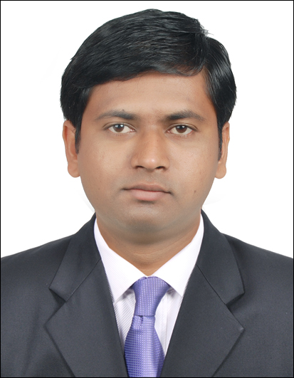  Mr. AMARDEEP ASHOK KAMBLE  EDUCATION  B. Com  PERSONAL DETAILS  Age / Date of Birth:  34 Years / 16th June 1986  Nationality: Indian.  Marital Status: Married.  Contact No:  7039541498 / 7304827112  Address:-  Room no :-13, Plot no :-E139, Jagruti CHS, Sector :-12, Kharghar, Navi Mumbai.  Pin code:- 410 210.  Email: amardeepkambleindia@gmail.com  PASSPORT DETAILS:-  PASSPORT NO. L2870600  Date of Issue :- 25/07/2013  Date of Expiry:- 24/07/2023 | CURRICULAM VITAE  Career Objective:  Goal directed and result-oriented professional with a strong work experience. Skilled communicator, Persuasive and adaptable. Self-motivated with energy, initiative, and focus. Professional, personable, and articulate in presentation. Able to work in any situation with any kind of pressure. A self-starter with high level of creativity and multi-tasking ability.  Professional Experience  - BROADSIDE MARINE PVT. LTD  (Junior Executive)  Admin Department  23rd Jan 2020 – 25th July 2020.  Job duties & responsibilities  - Handling PMS project work of Vessel Maintenance.  - Working on “BASSNET” PMS software.  - Updating vessel maintenance jobs, its procedure, required spares for that jobs, interval of maintenance, persons appointed for job etc.  - Keeping all details in excel sheet, Maintaining all data backup on company software.  - Co-ordinating with senior engineers, regarding works.  - Admin related and clerical office work.  - UPF INTERNATIONAL LLC (DUBAI) - (A division of AL MAYA GROUP)  (Data entry operator)  Inventory Department  Nov 2013 – 5th June 2016.  Job duties & responsibilities  - Handling database of local and overseas hypermarkets purchase orders.  - Preparing pick slip for warehouse transaction as per purchase order.  - Passed system entries of that purchase order and pick slip in company ERP software  (Oracle - JD Edwards).  - Handling Import/Export Documentation.  - Find H.S codes by tariff book or by website.  - Maintaining material stock records.  - Making Commercial Invoice and Packing list as per Order.  - Co-ordinating with Delivery Agents / Transporter for Delivery of Shipments & Planning for Delivery.  - Preparing Daily Status Report of Imports and Export Shipment.  - Follow-up with customers for payments and pink copies of invoices by mails.  - Preparing GRV (goods return vouchers).  - Preparing IS (Inventory sample) for salesmen.
- HCL INFOSYSTEMS LTD
(COMMERCIAL EXECUTIVE)
APR 2012 TO APR 2013
Job duties & responsibilities
- Collected pending payments of printers and photocopy machines
- Prepared invoices in excel.
- Follow-ups with the customers for pending payments by calling sending mails letters and making personal visit if necessary
- Prepared and maintained records of collections in soft copies and hard copies.

- THERMAX PVT LTD.
COMMERCIAL EXECUTIVE
JUN 2010 TO JAN 2011
Job duties & responsibilities
- Collected sales tax forms, maintained all records of soft copies & hard copies of S.T. Forms other related documents.
- Follow-up with customers by sending mails, Letters & reminders and personal visits when required. Covered total western region (M.P, Gujarat Maharashtra)

Educational Qualifications:
Sr. No. | Examinations Passed | Name of the University | Year of Passing | Class of Division
1 | 10th (SSC) | Mumbai University | 2003 | Pass Class
2 | 12th (HSC) | Mumbai University | 2005 | Second Class
3 | 3rd Year (B.com) | Mumbai University | 2009 | Pass Class

Computer Knowledge
- HARDWARE& NETWORKING
Completed (CCNS) course from CMS Institute.
(Software Installation, Assembling and Troubleshooting.)
- MS-CIT
- Familiar with ERP system (Oracle & JD Edwards)
- Tally9.0.
- English Typing (30 W.P.M)
- Advance Excel.
- Import Export management and Documentation Course.

Languages Known
- English, Hindi, Marathi.
Strengths
- Ability to manage change with ease.
- Able to perform under deadlines and pressure.
- Ability to identify problems and work positive solutions to the same.

Hobbies
- Playing Outdoor games, Travelling & Music.

Declaration
I hereby declare that all the above furnished details and particulars are true to the best of my knowledge and belief.
I am also confident of my ability to work in a team. And can support by relevant documents as when required.

Thanking You,

Yours sincerely,

Date : (Amardeep kamble)

Place :

