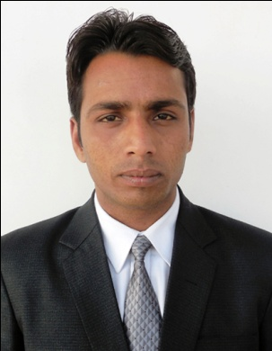**ASHU KUMAR**

Ho.no. 285 sector 21A

Faridabad Haryana

Contact no. 9560957507, 7417965027,

Email ID- ashu.kumar2k@gmail.com

**OBJECTIVE**

* Seeking challenging career and to be the part of reputed organization which can provide steady career growth along with job satisfaction and challenge to give valuable contribution in the progress of the organization.

**WORK EXPERIENCE**

* Currently Working with Kotak Mahindra prime ltd from 04 Aug. 2016 to till date

**JOB Responsibilities**

* Coordination with branches and local channels for the leads
* End to End customer service delivery form login to disbursement
* Maintaining MIS of different channels like Branch Banking / Dealer Channels and reporting /discussion to senior managers in terms of ROI.
* Maintaining client relationships for after sales service for future prospects / referral business
* Car display activities in corporates/branches for maximum lead generation**.**
* Managing end to end business for both individual and non- individual business
* Worked with **Kotak Mahindra Bank Business Loan Department** from 26 Sep.2014 to 3 Aug 2016.

**JOB Responsibilities**

* End to End customer service delivery form login to disbursement
* Complete knowledge about the company financials to help customer queries at the time of discussion and meetings.
* Maintaining MIS of different channels like Branch Banking / Dealer Channels and reporting /discussion to senior managers in terms of ROI.
* Maintaining client relationships for after sales service for future prospects / referral business

**PROFESSIONAL QUALIFICATION**

* I have completed Post Graduate Diploma in Management **(PGDM)** From Lotus Institute of Management Bareilly (U.P) (**Specialization in Marketing**) in 2014.

**EDUCATIONAL QUAIFICATION**

* Bachelor Of Arts From (MJPRU) Bareilly
* Intermediate U.P. Board ,2007
* High School U.P. Board , 2005

**COMPUTER SKILLS**

* Assembling, Disassembling, Maintenance& Troubleshooting of all Kinds of PCs & laptops.
* Basic Knowledge of Computer Fundamental
* MS Office 2003, 2007,2010
* Good knowledge of adobe Photoshop
* Internet Surfing

**EDUCATIONAL TRIP**

* 1 month educational trip in **IIT DELHI**.

**WORKSHOP ATTENDS**

* 60 day workshop on **M.S. Office** at lotus institute management Bareilly.
* 2day workshop on research methodology at lotus institute Bareilly.
* 1day workshop on ethic hacking conducted by A India InfoTech at lotus institute Bareilly.

**EXTRA CURRICULAR**

* Participated in college factions, stage committee, dancing committee and organize collage making competition and greeting card competition an annual fest **(LIMARTZZ’’-12)**

**SUMMER TRAINING**

* I have completed my Summer training in **HDFC LIFE INSURANCE COMPANY LIMITED** , 53 civil lines, Opp. railway institute Chopla Road , Bareilly.
* My summer training topic is “**RECRUITMENT OF FINANCIAL CONSULTANT IN HDFC LIFE**”

**PERSONAL INFORMATION**

* Date of Birth- : 13th January 1989
* Gender- : Male
* Marital Status- : Unmarried
* Father’s Name- : Mr. Durga Prasad
* Hobbies- : Interaction with new people & Playing cricket as a all rounder
* Languages known- : English & Hindi
* Nationality- : Indian

**DECLARATION**

I hereby confirm that the information given in this document is accurate and true to the best of my knowledge.

Date

Place: -Gurgaon **Ashu kumar**