CURRICULUM VITAE  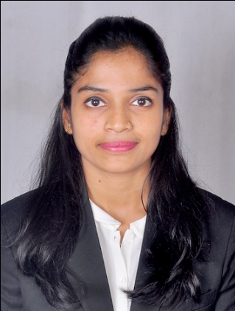  ARCHANA SHUKLA  Permanent Address:  502,Gala residency, Haji bapu road, Opp post office, Malad (East), Mumbai (Maharashtra)-4000097  E-Mail:  archana.sdf55@gmail.com  Contact No. : 8898258851  Personal Information:  Date of Birth :4th June 1996  Mother’s Name:Mrs. Savita Shukla  Father’s Name : Mr. Prakash Shukla  Sex :Female  Nationality :Indian | OBJECTIVE  To work with an organization which provides me opportunity to grow as a professional as well as individual and where my potentials can completely utilized to serve the organizations goal.  PROFESSIONAL QUALIFICATION  Qualification Specialization College Year of Passing  MBA Financial Planning International College of Financial Planning 2017-2019  Mutual Fund (Distributor) Cleared NISM 2018  Risk Analysis and Insurance Planning Cleared FPSB India 2018  SORM (Securities Operations & Risk Management) Cleared NISM 2020  Equity Derivatives Cleared NISM 2020  Currency Derivatives Cleared NISM 2020  ACADEMIC QUALIFICATION  - MBA in Financial Planning from International College Of Financial Planning, Mumbai.  - Bachelor of Commerce from THAKUR COLLEGE OF SCIENCE AND COMMERCE, MUMBAI UNIVERSITY.  - HSC from THAKUR COLLEGE OF SCIENCE AND COMMERCE, MAHARASHTRA BOARD.  - SSC from FATIMA DEVI ENGLISH HIGH SCHOOL, MAHARASHTRA BOARD.  AREA OF INTEREST  - Equity Advisor  - Mutual Fund Distributor  - Financial Planning  - Wealth Management
Marital Status: Single  Languages  Known :English, Hindi  Hobbies :Cooking, Listening music | WORK EXPERIENCE  - More than one year of Experience at IndiaInfoline(IIFL) Securities Ltd as RELATIONSHIP MANAGER.  Currently working As Equity Advisor at SBICAP Securities.(Equity Dealer)  COMPUTER PROFICIENCY  MS WORD, EXCEL,POWER-POINT,TALLY 9.0, FINANCIAL MODELLING.  DECLARATION  I hereby declare that all the above given information are true and correct to the best of my knowledge.  Place:- Mumbai  (ARCHANA SHUKLA)

