**Anoop Sharma**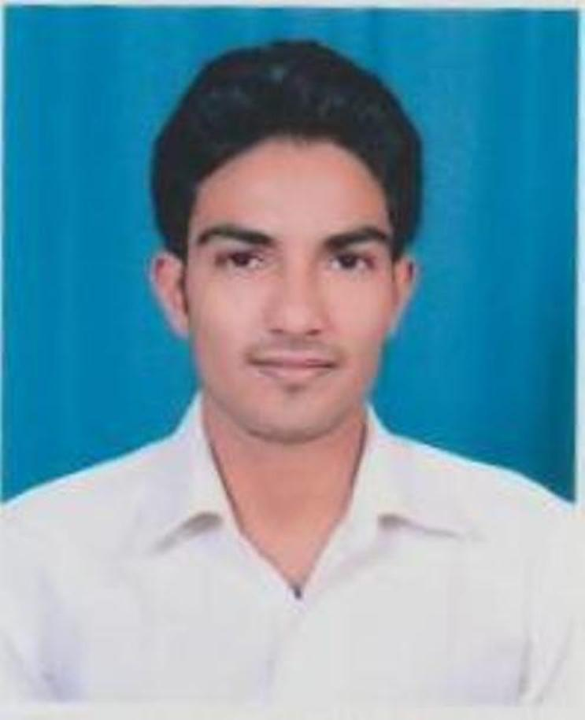

**H.N.2, MAHALAXMI GARDEN (KHORA)**

**GHAZIABAD (201309)**

Mobile. Num. *- 9873855131*

Email Id- [anoop.dhondiyal150@gmail](mailto:anoop.dhondiyal150@gmail).com

|  |
| --- |
|  |

**Career Objective:-**

* I aspire for a learning career in organization where my skills and abilities will get honored to contribute towards the company’s success and own personal growth

**Work Experience:-**

* One year Experience in EXL Service (Health and Life) as an Associate.

**Educational Qualification:-**

* MCA Passed from **AKTU** ( AIMT Colleges Greator Noida) in 2018.
* BCA Passed from CCSU (I.P. College Bulandshahr) in 2016.
* 12th Passed from **UP BOARD** in 2013.
* 10th Passed from **UP BOARD** in 2011**.**

**Certifications:-**

* Certification of the participation in ANDROID APPLICATION DEVELOPMENT
* Certification of the course in computer hardware/software technology DOS,WINDOWS,M.S OFFICE & TELLY 5.4,7.2,8.1,9.0

**Personal Abilities:-**

* Soft spoken
* Positive thinking
* Honest
* Interact with new people

**Achievement and college Events Participation:-**

Participation in Accurate Institute of Management & Technology

* Attended one day workshop on testing by Apex TG India Pvt . Ltd
* Attended one day workshop on BIG DATA by APTRON

**Personal Details:-**

* Fathers Name :Mr. Satish Chandra Sharma
* Date of Birth : 15/05/1996
* Gender : Male
* Nationality : Indian
* Languages Known :Hindi, English
* Marital Status :Unmarried

**Declaration:-**

**I hereby declare that the information furnished above is true and to best of my knowledge.**

**Place:**

**Date: Anoop Sharma**