**RESUME**

**NAME** : Sathish.P 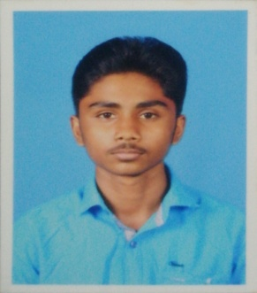

**ADDRESS** **:** N.Palanisamy,

8/11Kollapalayam, valluvakadu, **Email Id :**sathishps421@gmail.com  Emappalli(P.O),Namakkal(D.T), **Contact no :**9976838092

Thiruchengode(T.k) 6379503867

**CARREER OBJECTIVE :** To secure a challenging position where, I will effectively contribute my skills and services to the organization and there by enhancing my personal growth.

**EDUCATIONAL QUALIFICATION:**

|  |  |  |  |  |
| --- | --- | --- | --- | --- |
| **COURSE** | **BOARD /**  **UNIVERSITY** | **INSTITUTION** | **% OBTAINED** | **YEAR OF PASSING** |
| SSLC | State Board | KSR Rajammal Rangasamy Higher Secondary School | 73% | 2017 |
| Diploma EEE | Dote | KSR Polytechnic  College | 76% | 2020 |
| B.E(CS) | Autonomous | KSR College of Engineering | 3rd sem Up to 78% | Pursing |

**PROJECT DETAILS :**

**TITLE :** Non linear PWM controlled single phase boost mode grid connected photo voltaic inverter with limited storage inductance current.  **ABSTRACT:**The circuit topology,control strategy, steady state principle characteristics and designcriterion for the key circuit parametersof this kind of inverter areinvestigated in depth ,and important conclutions are obtained.

**EXTRA CURRICULAR ACTIVITIES**

* National Services Scheme
* Volley ball

**ACHIEVEMENT**

* 100 Percentage attendance in Diploma

**COCURICULAR ACTIVITIES**

* Closed Circuit Television
* LED Assembling

**PERSONAL DETAIL**

Name : P.sathish

Father’s name : N.palanisamy

Mother name : P.sumathi

D.O.B : 26.12.2001

Age : 18 years

Marital status : single

Gender : Male

Nationality : Indian

Languages known : English, Tamil

**PLACE : Yours fathifully**

**DATE :**

**P.sathish**