**RESUME**

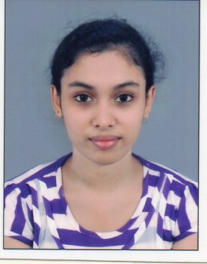**NAME :** SNIGDHA BASAK

**ADDRESS :** 6/C, GOLOCK DUTTA LANE.

KOLKATA – 700005

**Ph. No. :** 9831422774 / 9073136625

**E-mail I.D. :** [snigdha.basak07@gmail.com](mailto:snigdha.basak07@gmail.com)

**ACADEMIC QUALIFICATION :** ( In a descending order)

|  |  |  |  |  |  |
| --- | --- | --- | --- | --- | --- |
| QUALIFI-CATION | BOARD/  UNIVERSITY | NAME OF INSTITUTION | YEAR OF PASSING | REMARKS | % OF MARKS |
| B.COM | UNIVERSITY OF CALCUTTA | MAHARANI KASISWARI COLLEGE | 2019 | PASS | 60% |
| HIGHER SECONDARY EXAMINATION | WBCHSE | RAMJOY SEAL SISHU PATHSALA | 2016 | 1ST DIVISION | 69% |
| MADHYMIK EXAMINATION | WBHSE | RAMJOY SEAL SISHU PATHSALA | 2013 | 1ST DIVISION | 72% |

**PROFESSIONAL QUALIFICATION :**

* Certificate Course in Computer Basic from NIIT, 2016.
* Certificate Course in Accounting using Tally ERP 9.0 from ICA, 2017.

**PERSONAL PROFILE :**

* **Name**  **:** SNIGDHA BASAK
* **Father’s Name :** KASHINATH BASAK
* **Mother’s Name :** KRISHNA BASAK
* **Date of Birth :** 11/07/1996
* **Sex :** FEMALE
* **Marital Status :** Un-MARRIED
* **Religion :** HINDU
* **Nationality :** INDIAN
* **Languages Known :** Bengali ; English ; Hindi
* **Permanent Address :** 6/C, Golock Dutta Lane,

Kolkata- 700005.

**FIELDS of INTEREST :** Drawing ( completed 5th year from All India Fine Arts Association) ; Computer ; Designing etc.

**WORK EXPERIENCE :** 1 year

**DECLARATION :**

I hereby declare that the above-mentioned all information is correct to my knowledge and I bear the responsibility for its correctness.

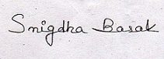

**Signature**

(SNIGDHA BASAK)